Final Q

Jake Cavaiani

12/9/2021

## French and Moose 2015 Discharge

The purpose of this script is to import raw PT data from each of our sites in 2015 (Moose, French), clean (out of water points, potential beaver dams, noisy data, remove a PT if data is bad etc.) and prepare to convert to continuous predicted discharge (Q)

Important NOTES: 1) Water level data is obtained from HOBO pressure transducers (PTs) that were installed in PVC pipes in streams, with the PT sitting on top of a rebar piece at bottom of pipe. Raw pressure from PTs were processed in HOBOware to correct for atmospheric pressure to get water depth. Atmospheric pressure was obtained from a PT installed at each site in a tree. HOWEVER, water depth is absolute PT depth, NOT actual water depth. To get actual water depth, we need a reference water depth from a time point in the water depth time series that is an accurate measure of the depth of the pt from the water surface. We do not have these (depth measurements from flow meter measurements were not done sufficiently close to PT locations to use).We have waterlevel surveys from Kate Broberg in 2020 and 2021 We must therefore rely on the rating curve to convert absolute water depth to continuous Q.

1. Date/time from HOBOware data is GMT-8, which is Alaska Daylight Time, which is the correct timezone for this project in summer (AK is in GMT-9 March-November when daylight savings is not observed). Data/time therefore needs to be formatted but not timezone-converted.

Step 1: import raw data hoboware files which is site, datetime, absolute pressure and water level Step 2: Clean errant points within the data that could be due to installation/decommission or gaps in data Step 3: Write final output of cleaned site, datetime, absolute pressure and water level Step 4: import Qsummary document to generate rating curves of Q and pressure Step 5: clean errant points in regression Step 6: apply rating curve to generate continuous predicted discharge at each site Step 7: Output final discharge as csv.

2015 data is read from DoD->2015 AK sensors->Discharge->discharge->pressure transducer-> “PT_Site_Compiled” 2015 data was taken att 5 minute intervals

##### Checking Raw PT data

## Raw Moose

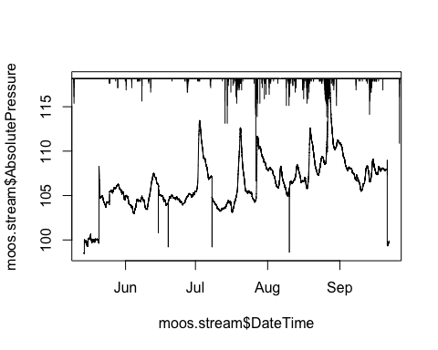 There is a big increase in middle to end of may that doesnt seem to be real from precip , and then a lot of vertical drops in middle of June, July, August (potentially cleanning points) and then at the end of september we get a big drop, this is when the site was taken out…(PT was taken out on the 21st)… let the cleaning commence!

## Moose 1.0

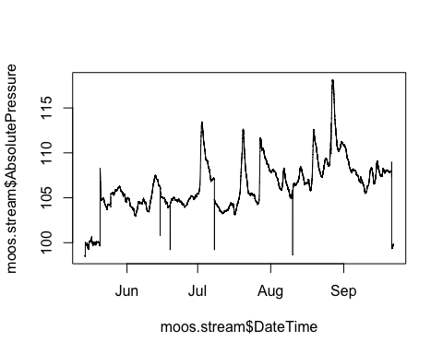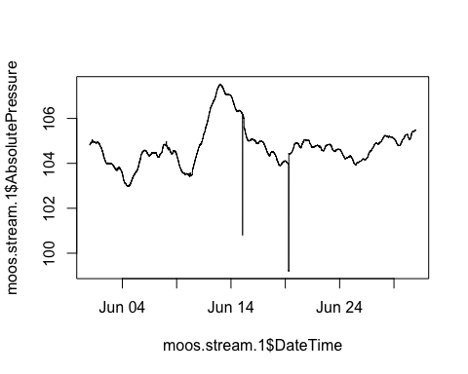

## [1] 4052 5270 5271 5272 5273 5274 5275 5276 5277

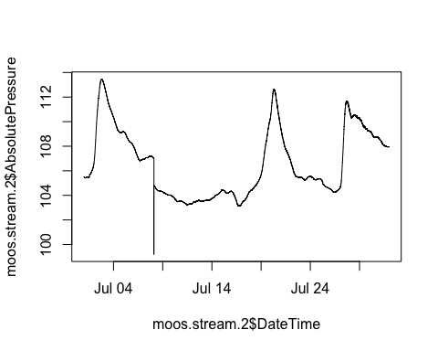

## [1] 2047

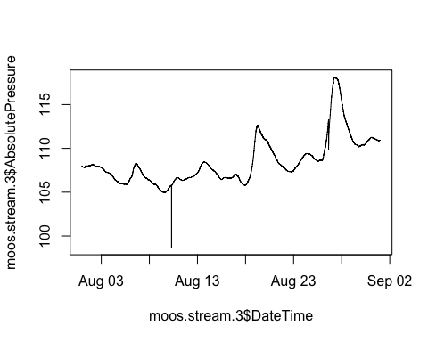

## [1] 2679 2680 2681

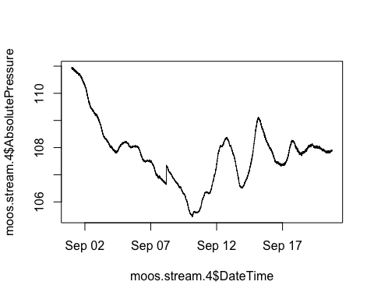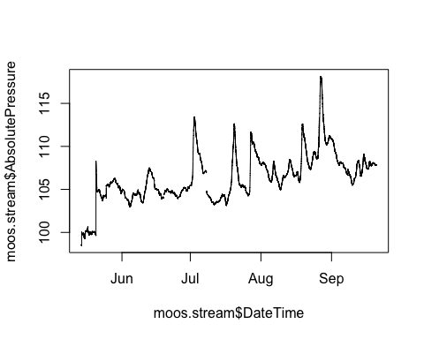 1) Clipped off the take out date (anything after 2015-09-20 18:30:00) 2) Set vertical drops in raw data to NA’s 3) NEED TO DO NA INTERPRET

### Impute missing observations in pressure for Moose

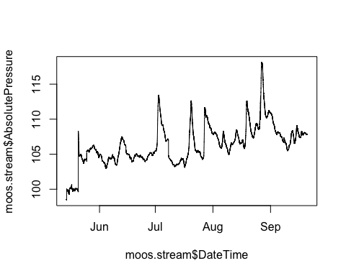 1) middle of July gap is just connected

### Export csv to DoD_Discharge->PT_data->2015

## Raw FRCH

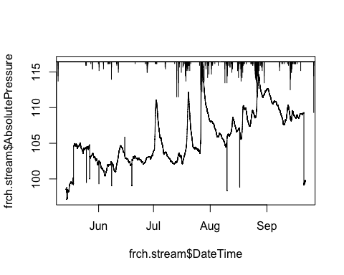

Similarily to Moose There is a big increase in middle to end of may that doesnt seem to be real from precip , and then a lot of vertical drops in middle of June, July, August (potentially cleanning points) and then at the end of september we get a big drop, this is when the site was taken out…(PT was taken out on the 21st)… let the cleaning commence!

### French 1.0

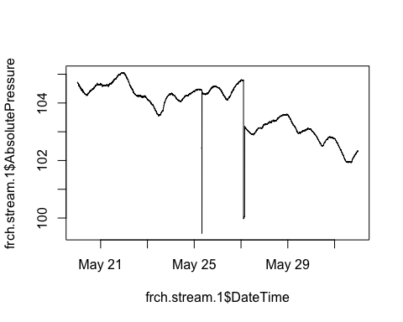

## [1] 1535 2047 2048 2049 2050 2051 2052 2053 2054 2055 2056 2057 2058 2059 2060  
## [16] 3305 3306 3307 3308 3309 3310 3311 3312 3313 3314 3315 3316 3317 3318 3319  
## [31] 3320 3321 3322 3323 3324 3325 3326 3327 3328 3329 3330 3331 3332 3333 3334  
## [46] 3335 3336 3337 3338 3339 3340 3341 3342 3343 3344 3345 3346 3347 3348 3349  
## [61] 3350 3351 3352 3353 3354 3355 3356 3357 3358 3359 3360 3361 3362 3363 3364  
## [76] 3365 3366 3367 3368 3369 3370 3371 3372 3373 3374 3375 3376 3377 3378 3379  
## [91] 3380 3381 3382 3383 3384

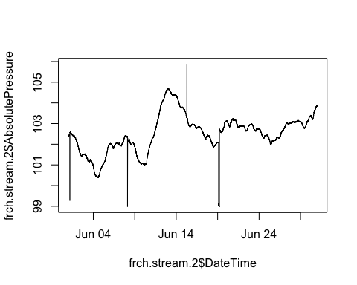

## [1] 49 2052 5213 5214 5215 5216 5217 5218 5219 5220 5221 5222 5223 5224 5225  
## [16] 5226 5227 5228 5229 5230 5231 5232 5233 5234 5235 5236 5237 5238 5239 5240  
## [31] 5241

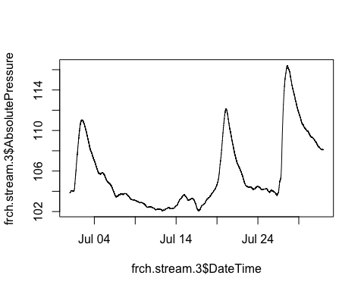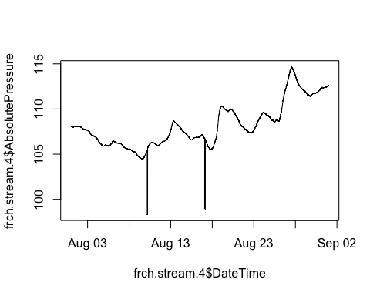

## [1] 2641 2642 2643 2644 2645 2646 2647 2648 2649 2650 2651 2652 2653 2654 2655  
## [16] 2656 4631 4632 4633 4654

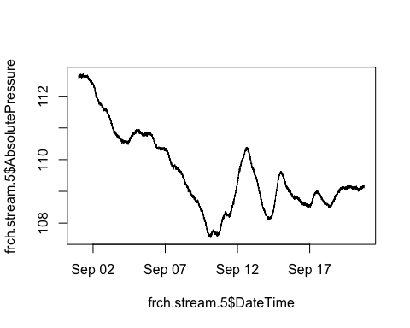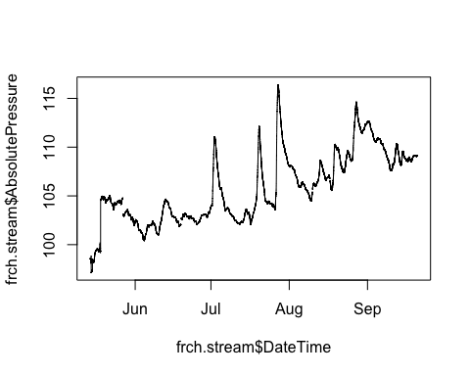 1) Clipped off the take out date (anything after 2015-09-20 18:30:00) 2) Set vertical drops in raw data to NA’s 3) NEED TO DO NA INTERPRET (na_kalman)

### Impute missing observations in pressure for Moose

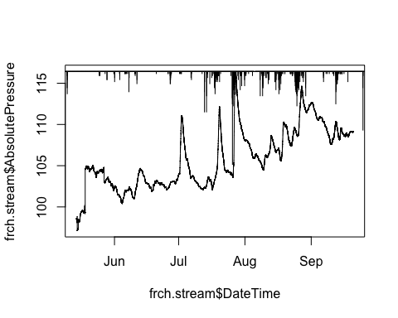

### Export csv to DoD_Discharge->PT_data->2015

### Observed Discharge at French and Moose

Slugs were the only method of discharge for 2015

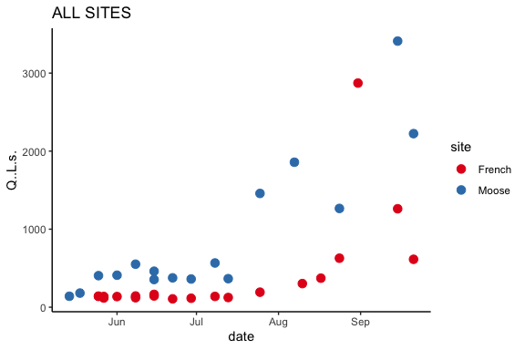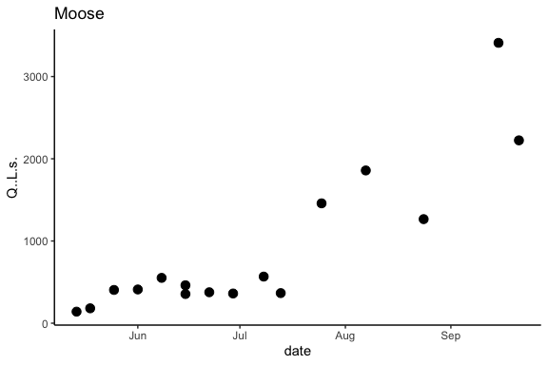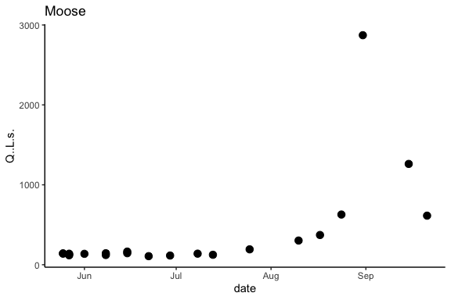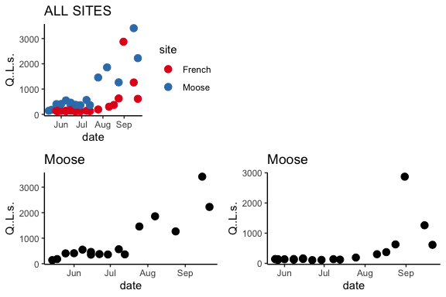 This is from the DOD Q Summary csv that is DoD Project->2015 AK sensors ->Discharge

### Raw Rating Curve with Moose 1 Pressure Transducer

## Joining, by = c("DateTime", "site")

## `geom_smooth()` using formula 'y ~ x'

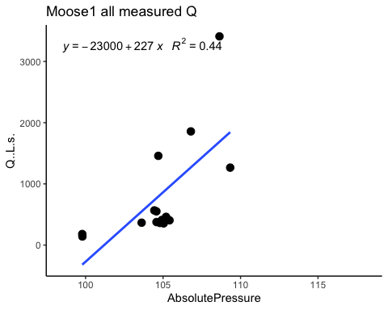 The most upper measurement is probably bad. I am going to take it out

### Rating Curve with Moose 1 Pressure Transducer 2.0

## Joining, by = c("DateTime", "site")

## `geom_smooth()` using formula 'y ~ x'

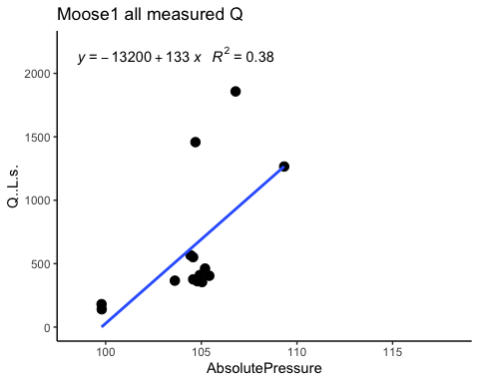

## Joining, by = c("DateTime", "site")  
## `geom_smooth()` using formula 'y ~ x'

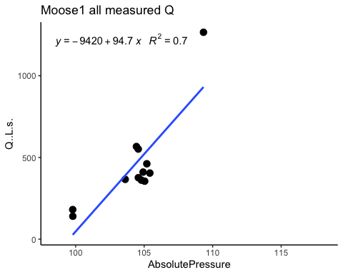

## `geom_smooth()` using formula 'y ~ x'  
## `geom_smooth()` using formula 'y ~ x'  
## `geom_smooth()` using formula 'y ~ x'

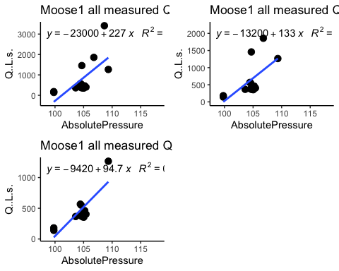 1) Removed the point that had a Q > 3000 L/s - This R^2 value is actually lower 2) Removed the point that had a Q > 1300 L/s - best R^2 value

### Moose1 (light blue) and Moose2 and Moose3 (brown) with observed Q.

#### Black points are observed Q

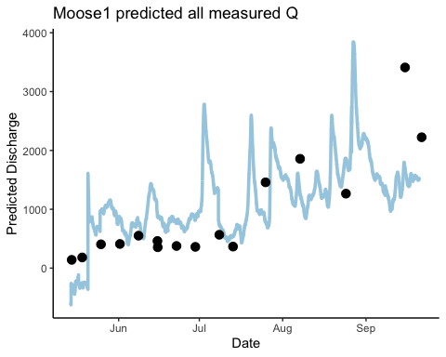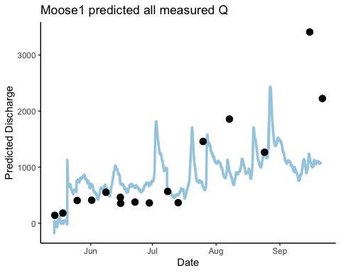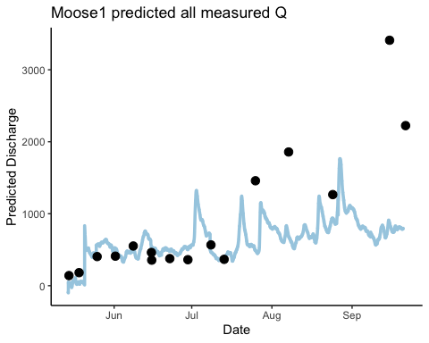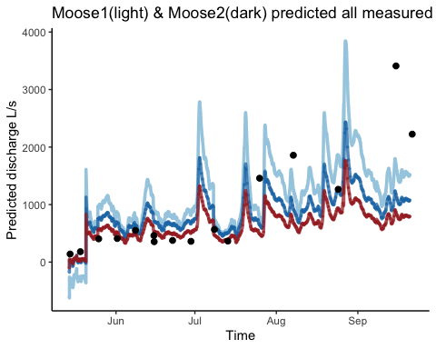 This is only from PT rather than waterlevel, is that going to be a problem? Moose1 is from the first RC and Moose2 is from the second RC and Moose3 is from the third RC. It appears that it gets worse to predict the higher discharges as we go through our iteration of RC’s.

### Export csv to DoD_Discharge->PT_data->2015

### Raw Rating Curve with French 1 Pressure Transducer

## Joining, by = c("DateTime", "site")

## `geom_smooth()` using formula 'y ~ x'

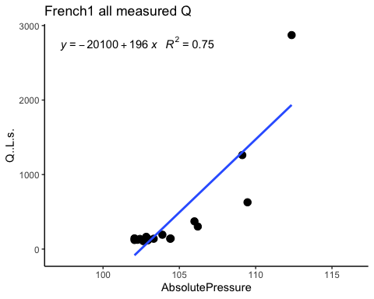 The most upper measurement is probably bad. I am going to take it out

### Rating Curve French PT 2.0

## Joining, by = c("DateTime", "site")

## `geom_smooth()` using formula 'y ~ x'

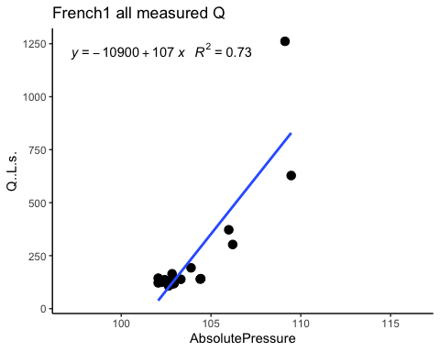 R^2 value goes down

## French 1 Calculated Q (L/s)

#### Black points are observed Q

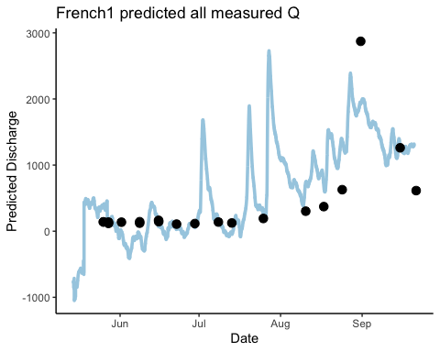 This is not great considering there are negative values

### Export csv to DoD_Discharge->PT_data->2015

### Export csv to DoD_Discharge->PT_data->2015

# French and Moose 2018 Discharge

2018 data is read from DoD->2018 sesors French Moose->Q->Qprocessing->“French_stream_PT_may-oct2018_20005933.csv” Wading rods and slugs were used to measure discrete Q during site visit

##### Checking closeness between the two Pressure Transducers

1:1 line in green 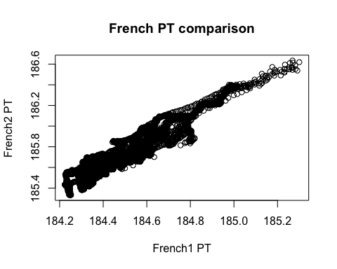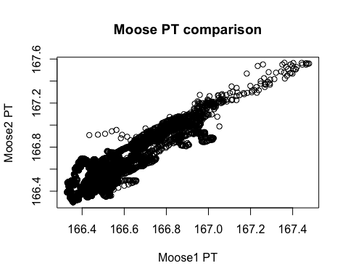

### French

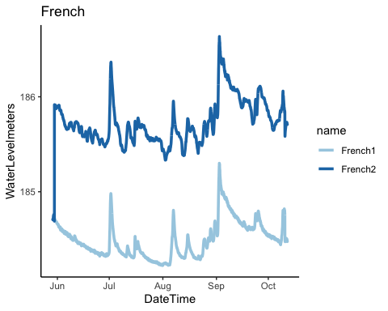 There looks like an error when we calculated depth. Tom says that we can adjust the difference of the wrong one to make them agree, then remeasure them next year. French 2 also looks “noisier” 1) dumping French 2

### Raw French 1

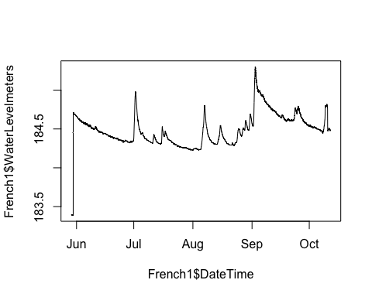 The beginning is probably when this was installed, I will remove that. the spije in October is confirmed with French 2 so that is real. let the cleaning commence!

### French PT 1 2.0

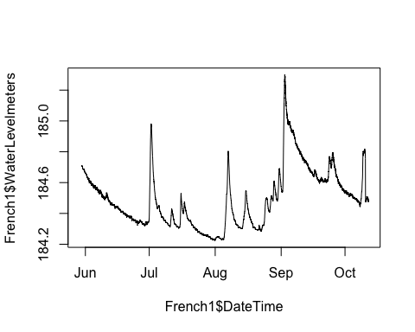 1) set the beginning of the dataframe where PT was taking out of water points to NA 2) we are dumping French PT2 due to it being too “noisy”

### export PT data to csv to DoD_Discharge->PT_data->2018

### Raw Moose

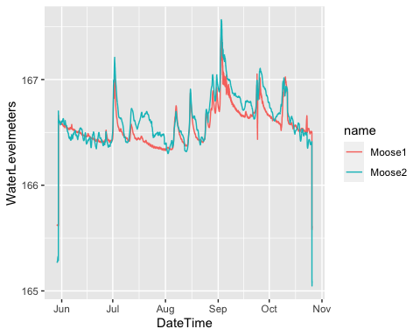 Moose2 looks a little weird during mid July, where it doens’t agree w/ Moose 1. Moose 2 seems a lot noisier….we are dumping moose 2

### Moose PT 1 2.0

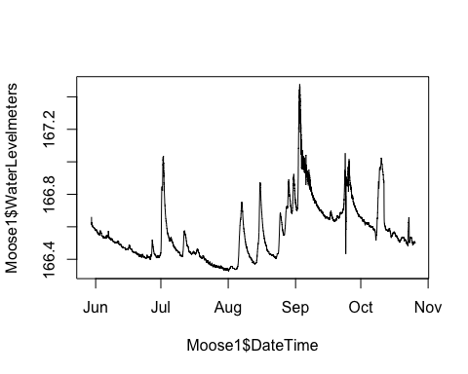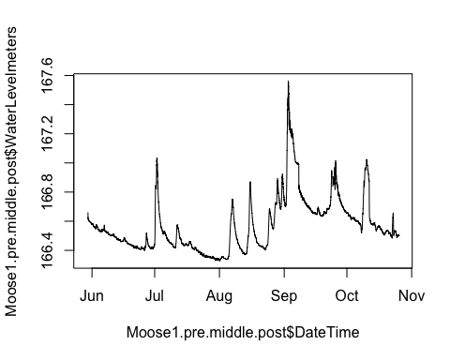 1) Removed the beginning and end of the dataframe where the PT was out of water 2) Cleaned the receding limb of the september storm and replaced it with the receding limb from the second PT however now we get a steep drop for the end of the timeseries. Should I shift the back half of the dataframe up? 3) set middle of Setember vertical drop to NAs 4) still need to do NA INTERPRET!

### Impute missing observations in pressure for MOOS

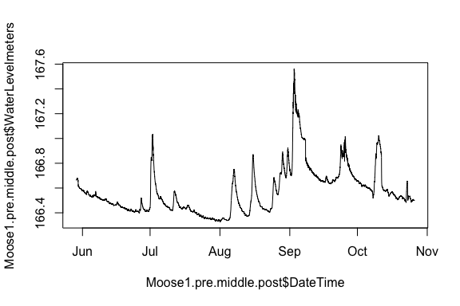 ### Observed Discharge at French and Moose

* from Rachel Voight For the days we used the HOBO, there are two “measurements” since I did not know which slug solution was used, so I calculated it with the two likely slug batches. We changed where we were measuring Q at Moose; the first two times we measured Q, we did it downstream of the sensors near the actual pressure transducer. We likely underestimated Q for those few measurements at the old spot downstream of the sensors.

### export PT data to csv to DoD_Discharge->PT_data->2018

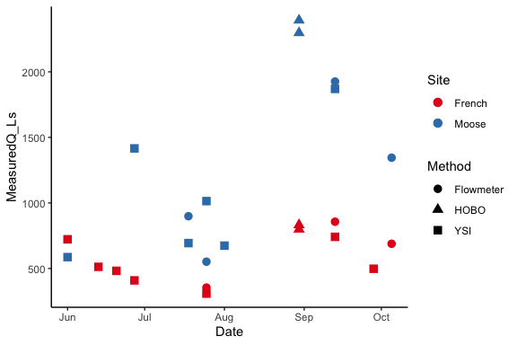

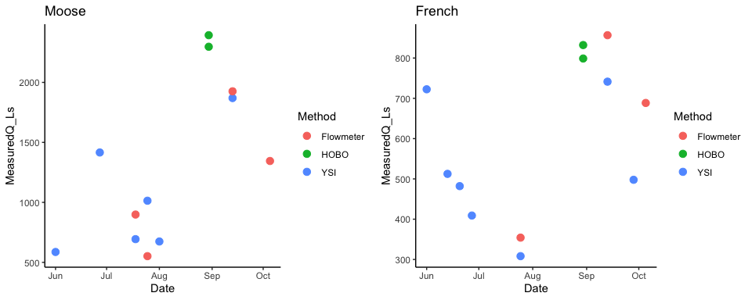

### Raw Rating Curve with Moose 1 Pressure Transducer

## Joining, by = "DateTime"

## `geom_smooth()` using formula 'y ~ x'

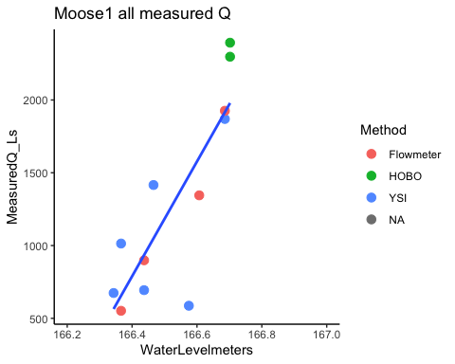

##   
## Call:  
## lm(formula = moose1comb$MeasuredQ_Ls ~ moose1comb$WaterLevelmeters)  
##   
## Residuals:  
## Min 1Q Median 3Q Max   
## -892.01 -137.60 -13.08 328.47 414.47   
##   
## Coefficients:  
## Estimate Std. Error t value Pr(>|t|)   
## (Intercept) -655003.6 134968.0 -4.853 0.000668 ***  
## moose1comb$WaterLevelmeters 3941.1 810.5 4.863 0.000659 ***  
## ---  
## Signif. codes: 0 '***' 0.001 '**' 0.01 '*' 0.05 '.' 0.1 ' ' 1  
##   
## Residual standard error: 385.2 on 10 degrees of freedom  
## (7193 observations deleted due to missingness)  
## Multiple R-squared: 0.7028, Adjusted R-squared: 0.6731   
## F-statistic: 23.65 on 1 and 10 DF, p-value: 0.0006587

* Rachel -While we only had 4 measurements from the flow meter, they agree well with our trendline and slug Q. *Jake - I will remove the Hobo points in this regression

## Joining, by = "DateTime"

## `geom_smooth()` using formula 'y ~ x'

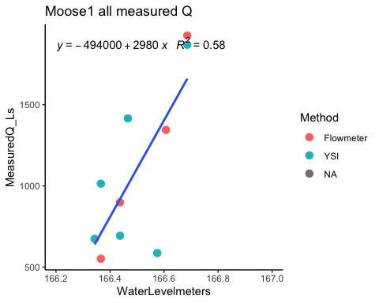

##   
## Call:  
## lm(formula = moose2comb$MeasuredQ_Ls ~ moose2comb$WaterLevelmeters)  
##   
## Residuals:  
## Min 1Q Median 3Q Max   
## -743.40 -137.13 7.04 251.46 410.44   
##   
## Coefficients:  
## Estimate Std. Error t value Pr(>|t|)   
## (Intercept) -494491.1 150037.5 -3.296 0.0109 *  
## moose2comb$WaterLevelmeters 2976.6 901.1 3.303 0.0108 *  
## ---  
## Signif. codes: 0 '***' 0.001 '**' 0.01 '*' 0.05 '.' 0.1 ' ' 1  
##   
## Residual standard error: 355.7 on 8 degrees of freedom  
## (7194 observations deleted due to missingness)  
## Multiple R-squared: 0.577, Adjusted R-squared: 0.5241   
## F-statistic: 10.91 on 1 and 8 DF, p-value: 0.01081

1. removed the HOBO ware points

## Estimated Q from Moose 1 PT.

#### Black points are observed Q

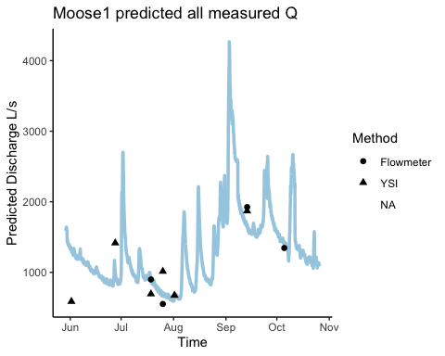

This is the final discharge plot from the RC without the HOBO ware points

### export PT data to csv to DoD_Discharge->Prredicted_Discharge->2018

## French Creek

### Raw Rating Curve French 1 Pressure Transducer

## Joining, by = "DateTime"

## `geom_smooth()` using formula 'y ~ x'

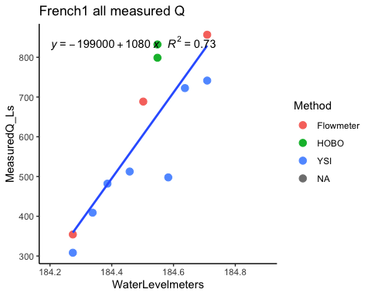

##   
## Call:  
## lm(formula = French1comb$MeasuredQ_Ls ~ French1comb$WaterLevelmeters)  
##   
## Residuals:  
## Min 1Q Median 3Q Max   
## -195.36 -46.80 -11.97 41.21 176.95   
##   
## Coefficients:  
## Estimate Std. Error t value Pr(>|t|)   
## (Intercept) -198904.1 38127.3 -5.217 0.000392 ***  
## French1comb$WaterLevelmeters 1081.3 206.7 5.233 0.000383 ***  
## ---  
## Signif. codes: 0 '***' 0.001 '**' 0.01 '*' 0.05 '.' 0.1 ' ' 1  
##   
## Residual standard error: 105.5 on 10 degrees of freedom  
## (6510 observations deleted due to missingness)  
## Multiple R-squared: 0.7325, Adjusted R-squared: 0.7057   
## F-statistic: 27.38 on 1 and 10 DF, p-value: 0.0003829

Will remove the two HOBOware points

## Joining, by = "DateTime"

## `geom_smooth()` using formula 'y ~ x'

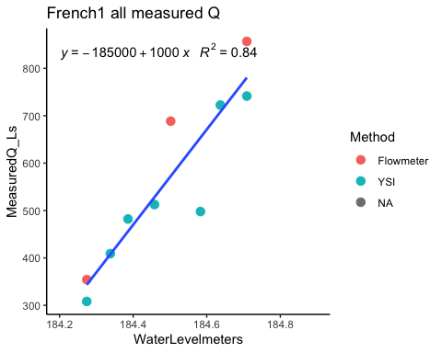

##   
## Call:  
## lm(formula = French1comb$MeasuredQ_Ls ~ French1comb$WaterLevelmeters)  
##   
## Residuals:  
## Min 1Q Median 3Q Max   
## -195.36 -46.80 -11.97 41.21 176.95   
##   
## Coefficients:  
## Estimate Std. Error t value Pr(>|t|)   
## (Intercept) -198904.1 38127.3 -5.217 0.000392 ***  
## French1comb$WaterLevelmeters 1081.3 206.7 5.233 0.000383 ***  
## ---  
## Signif. codes: 0 '***' 0.001 '**' 0.01 '*' 0.05 '.' 0.1 ' ' 1  
##   
## Residual standard error: 105.5 on 10 degrees of freedom  
## (6510 observations deleted due to missingness)  
## Multiple R-squared: 0.7325, Adjusted R-squared: 0.7057   
## F-statistic: 27.38 on 1 and 10 DF, p-value: 0.0003829

1. Removed the HOBOware points

## French 1 Calculated Q (L/s)

#### Black points are observed Q

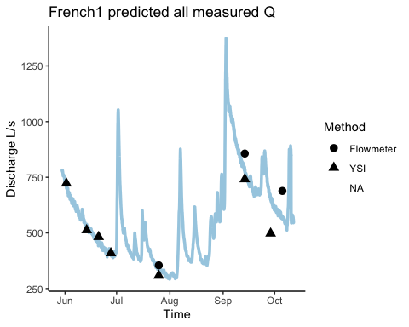 This doesnt look too shabby!

### export PT data to csv to DoD_Discharge->Prredicted_Discharge->2018

### export PT data to csv to DoD_Discharge->Prredicted_Discharge->2018

* We rock at discharge!!!

2019 data is read from DoD->2019 AK sensors->2019 Sensor data ->PT->DoD 2019 PT depth corrected for atm  
Wading rods and slugs were used to measure discrete Q during site visit Includes all sites (Moose, French, Poker, Vault, Stuart)

#2019 data is read in from DoD->2019 ak sensors->2019 sensor data->Q -> Pressure Transducer Data->Depth->‘site’

##### Checking closeness between the two Pressure Transducers

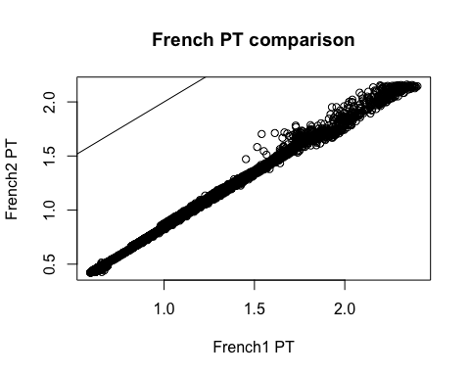 Looks pretty good

##### Checking Raw PT data

## Raw Moose

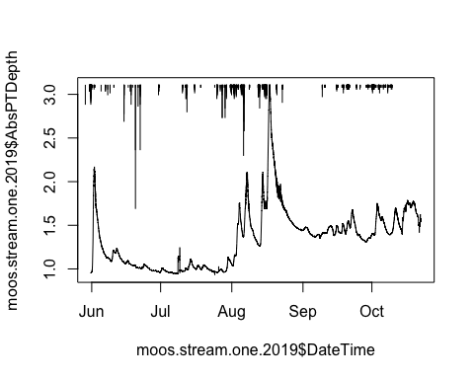 let the cleaning commence! ## Moose 2.0 ## 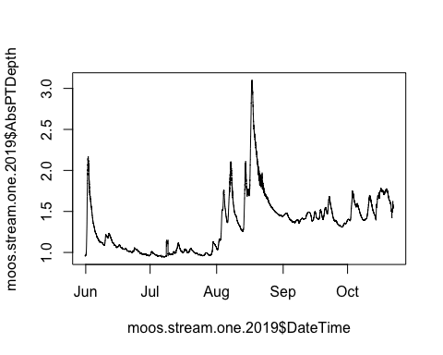 1)removed vertical bars in dataframe ? Spike in early Julyish does have rainfall close to it….is it real? Middle of October? Ice on? Should I clip middle of October, French was removed on October 10th according to the field notebook

### export PT data to csv to DoD_Discharge->PT_data->2019

### Observed Discharge at all sites

Slugs and wading rods were used for 2019 observed Q

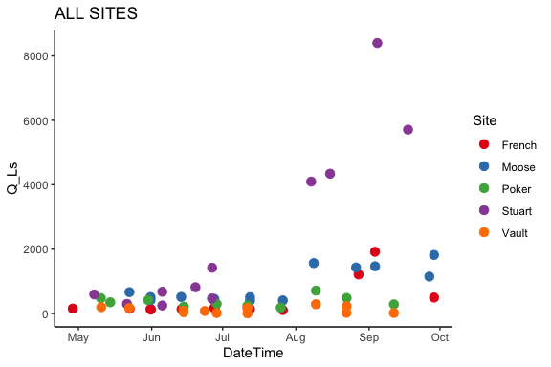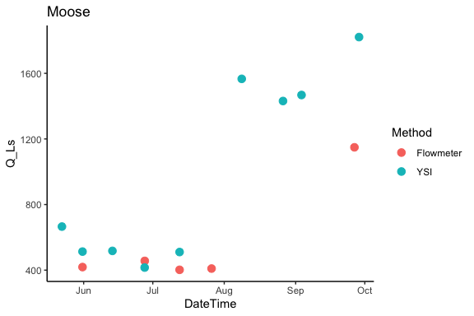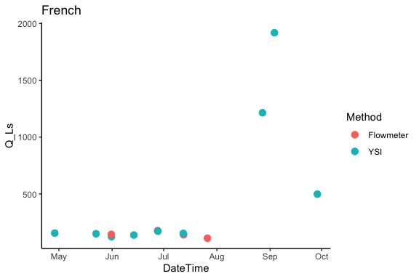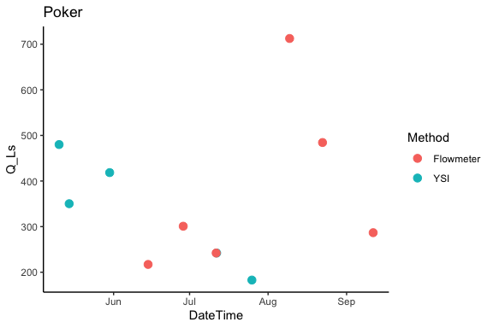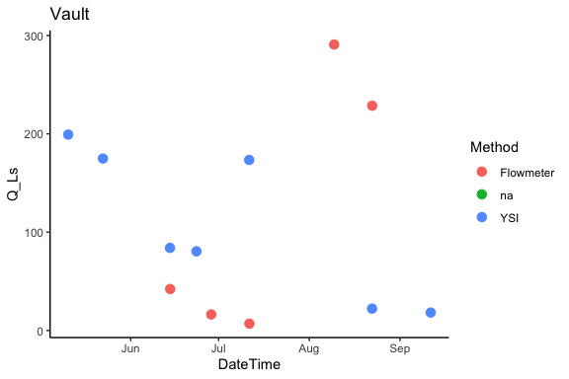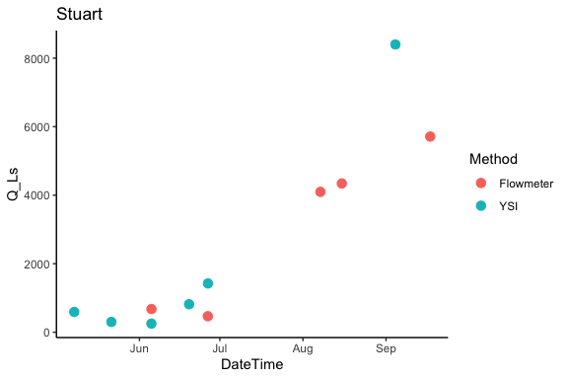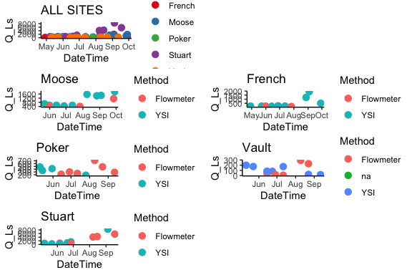 ### Raw Rating Curve with Moose 1 Pressure Transducer

## Joining, by = c("Site", "DateTime")

##   
## Call:  
## lm(formula = Moose1comb.2019$Q_Ls ~ Moose1comb.2019$AbsPTDepth)  
##   
## Residuals:  
## Min 1Q Median 3Q Max   
## -236.06 -127.32 -42.25 8.70 699.33   
##   
## Coefficients:  
## Estimate Std. Error t value Pr(>|t|)   
## (Intercept) -1460.6 410.3 -3.560 0.006118 **   
## Moose1comb.2019$AbsPTDepth 1969.8 332.5 5.925 0.000222 ***  
## ---  
## Signif. codes: 0 '***' 0.001 '**' 0.01 '*' 0.05 '.' 0.1 ' ' 1  
##   
## Residual standard error: 268.2 on 9 degrees of freedom  
## (13789 observations deleted due to missingness)  
## Multiple R-squared: 0.7959, Adjusted R-squared: 0.7733   
## F-statistic: 35.1 on 1 and 9 DF, p-value: 0.0002221

## `geom_smooth()` using formula 'y ~ x'

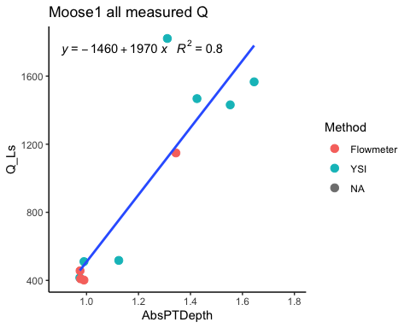 Not too shabby, im going to remove the top YSI point

### Raw Rating Curve with Moose 1 Pressure Transducer

## Joining, by = c("Site", "DateTime")

##   
## Call:  
## lm(formula = Moose2comb.2019$Q_Ls ~ Moose2comb.2019$AbsPTDepth)  
##   
## Residuals:  
## Min 1Q Median 3Q Max   
## -175.338 -51.427 -5.621 46.981 218.936   
##   
## Coefficients:  
## Estimate Std. Error t value Pr(>|t|)   
## (Intercept) -1384.5 171.3 -8.085 4.05e-05 ***  
## Moose2comb.2019$AbsPTDepth 1848.0 139.7 13.231 1.02e-06 ***  
## ---  
## Signif. codes: 0 '***' 0.001 '**' 0.01 '*' 0.05 '.' 0.1 ' ' 1  
##   
## Residual standard error: 111.7 on 8 degrees of freedom  
## (13790 observations deleted due to missingness)  
## Multiple R-squared: 0.9563, Adjusted R-squared: 0.9508   
## F-statistic: 175.1 on 1 and 8 DF, p-value: 1.015e-06

## `geom_smooth()` using formula 'y ~ x'

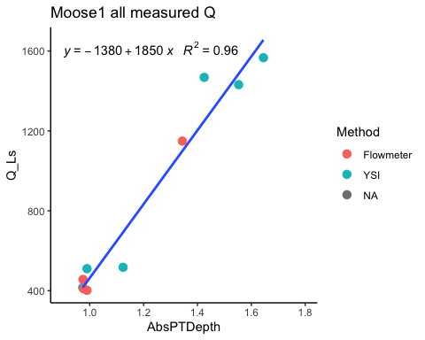 That’s better, I will use this for the predicted discharge

### Predicted Q MOOS PT1

#### Black points are observed Q

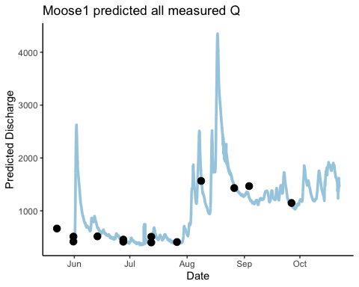 Not too shabby

### export PT data to csv to DoD_Discharge->Predicted_discharge->2019

## Raw French PT1

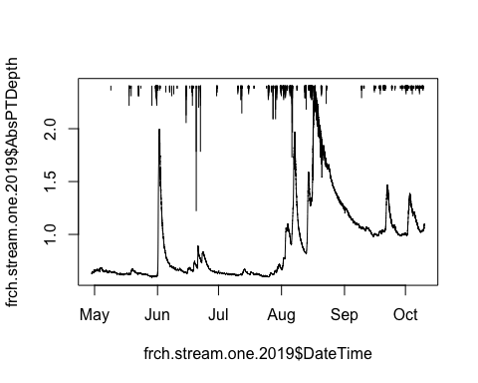 Looks good. I am going to replace the noisy-ness of the receding limb in the big august storm with FRCH PT2 as it is less noisy let the cleaning commence!

# FRCH PT1 2.0

## [1] 10549

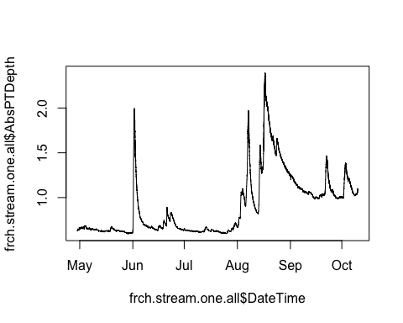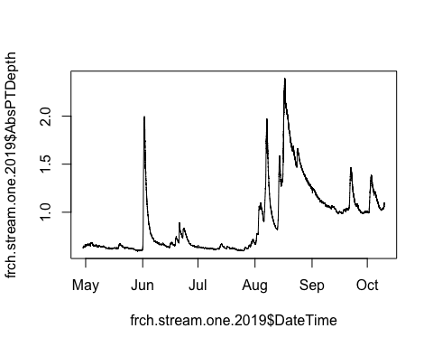 1) replaced the noisy receding limb in the big end of August storm of PT1 with the more constant data of PT2

## Raw French PT2

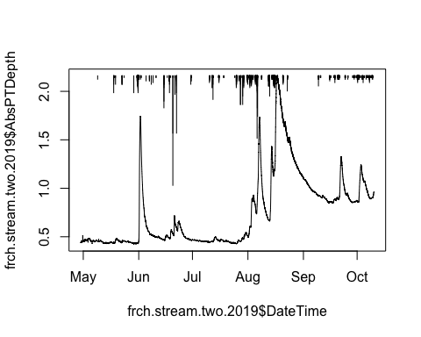 Going to clean some of the vertical bars in may but other than that this looks pretty good! let the cleaning commence ## FRCH PT2 2.0 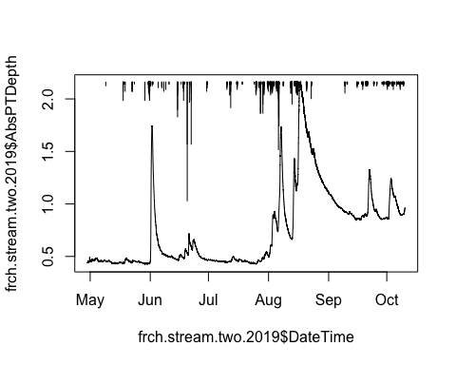 1) removed vertical bars early on in season

### export PT data to csv to DoD_Discharge->PT_data->2019

### Raw Rating Curve with French 1 Pressure Transducer

## Joining, by = c("Site", "DateTime")

##   
## Call:  
## lm(formula = French1comb.2019$Q_Ls ~ French1comb.2019$AbsPTDepth)  
##   
## Residuals:  
## Min 1Q Median 3Q Max   
## -371.71 -46.80 -13.33 25.72 749.71   
##   
## Coefficients:  
## Estimate Std. Error t value Pr(>|t|)   
## (Intercept) -1015.5 259.5 -3.914 0.002893 **   
## French1comb.2019$AbsPTDepth 1860.6 320.8 5.800 0.000173 ***  
## ---  
## Signif. codes: 0 '***' 0.001 '**' 0.01 '*' 0.05 '.' 0.1 ' ' 1  
##   
## Residual standard error: 285.8 on 10 degrees of freedom  
## (15711 observations deleted due to missingness)  
## Multiple R-squared: 0.7709, Adjusted R-squared: 0.748   
## F-statistic: 33.64 on 1 and 10 DF, p-value: 0.0001729

## `geom_smooth()` using formula 'y ~ x'

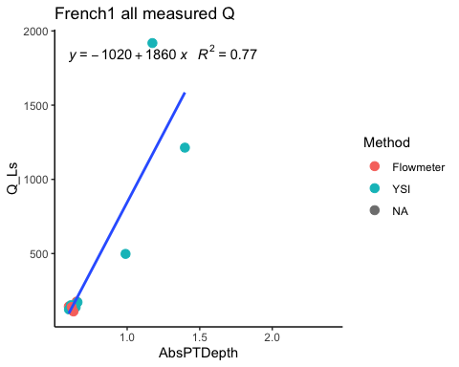 Lots of points that are clustered at the bottom. I will remove the 3 large YSI points

## Joining, by = c("Site", "DateTime")

##   
## Call:  
## lm(formula = French2comb.2019$Q_Ls ~ French2comb.2019$AbsPTDepth)  
##   
## Residuals:  
## Min 1Q Median 3Q Max   
## -36.779 -7.224 3.299 13.574 18.547   
##   
## Coefficients:  
## Estimate Std. Error t value Pr(>|t|)  
## (Intercept) -173.4 192.8 -0.899 0.398  
## French2comb.2019$AbsPTDepth 507.9 307.4 1.652 0.142  
##   
## Residual standard error: 19.08 on 7 degrees of freedom  
## (15714 observations deleted due to missingness)  
## Multiple R-squared: 0.2805, Adjusted R-squared: 0.1778   
## F-statistic: 2.73 on 1 and 7 DF, p-value: 0.1425

## `geom_smooth()` using formula 'y ~ x'

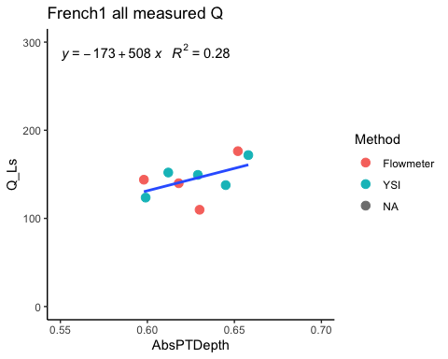 Not as good of an R^2

### Raw Rating Curve with French 2 Pressure Transducer

## Joining, by = c("Site", "DateTime")

##   
## Call:  
## lm(formula = French3comb.2019$Q_Ls ~ French3comb.2019$AbsPTDepth)  
##   
## Residuals:  
## Min 1Q Median 3Q Max   
## -358.33 -44.52 -5.42 24.09 732.91   
##   
## Coefficients:  
## Estimate Std. Error t value Pr(>|t|)   
## (Intercept) -658.4 199.2 -3.306 0.007936 **   
## French3comb.2019$AbsPTDepth 1771.3 300.9 5.887 0.000154 ***  
## ---  
## Signif. codes: 0 '***' 0.001 '**' 0.01 '*' 0.05 '.' 0.1 ' ' 1  
##   
## Residual standard error: 282.6 on 10 degrees of freedom  
## (15708 observations deleted due to missingness)  
## Multiple R-squared: 0.7761, Adjusted R-squared: 0.7537   
## F-statistic: 34.65 on 1 and 10 DF, p-value: 0.0001538

## `geom_smooth()` using formula 'y ~ x'

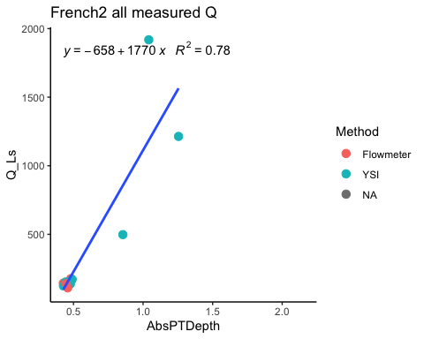 Same thing as FRCH 1. Next plot will be without the 3 high YSI points

## Joining, by = c("Site", "DateTime")

##   
## Call:  
## lm(formula = French2comb.2019$Q_Ls ~ French2comb.2019$AbsPTDepth)  
##   
## Residuals:  
## Min 1Q Median 3Q Max   
## -36.779 -7.224 3.299 13.574 18.547   
##   
## Coefficients:  
## Estimate Std. Error t value Pr(>|t|)  
## (Intercept) -173.4 192.8 -0.899 0.398  
## French2comb.2019$AbsPTDepth 507.9 307.4 1.652 0.142  
##   
## Residual standard error: 19.08 on 7 degrees of freedom  
## (15714 observations deleted due to missingness)  
## Multiple R-squared: 0.2805, Adjusted R-squared: 0.1778   
## F-statistic: 2.73 on 1 and 7 DF, p-value: 0.1425

## `geom_smooth()` using formula 'y ~ x'

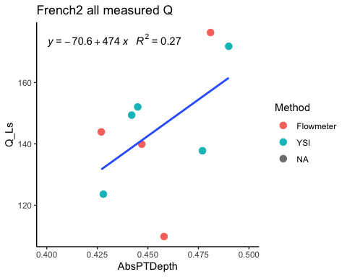 I will remove the low flowmeter point for the next plot

## Joining, by = c("Site", "DateTime")

##   
## Call:  
## lm(formula = French5comb.2019$Q_Ls ~ French5comb.2019$AbsPTDepth)  
##   
## Residuals:  
## Min 1Q Median 3Q Max   
## -360.35 -48.27 1.21 18.96 732.37   
##   
## Coefficients:  
## Estimate Std. Error t value Pr(>|t|)   
## (Intercept) -649.5 217.5 -2.987 0.015275 *   
## French5comb.2019$AbsPTDepth 1763.4 321.0 5.493 0.000384 ***  
## ---  
## Signif. codes: 0 '***' 0.001 '**' 0.01 '*' 0.05 '.' 0.1 ' ' 1  
##   
## Residual standard error: 297.5 on 9 degrees of freedom  
## (15709 observations deleted due to missingness)  
## Multiple R-squared: 0.7703, Adjusted R-squared: 0.7447   
## F-statistic: 30.17 on 1 and 9 DF, p-value: 0.0003836

## `geom_smooth()` using formula 'y ~ x'

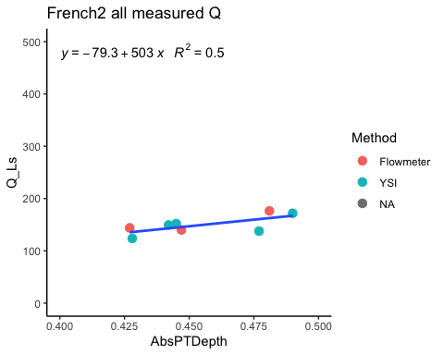 This is the RC I will use for predicted Q

### Predicted Q FRCH PT1

#### Black points are observed Q

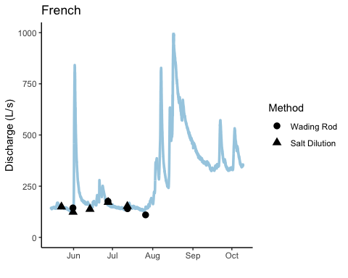 Without a big range in observed Q this is the best we can do

### Predicted Q FRCH PT2

#### Black points are observed Q

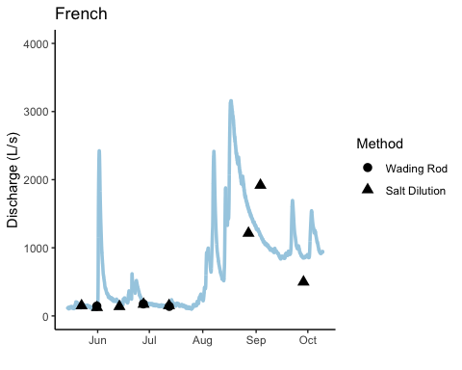 This gives us much higher Q

### Compare FRCH PT1 and PT2

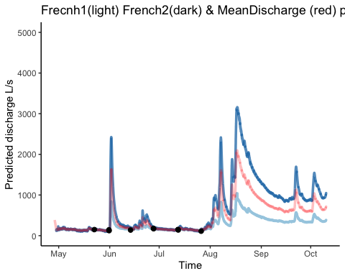 When it comes to the higher Q they are way off.

### export PT data to csv to DoD_Discharge->Predicted_Discharge->2019

## Raw Poker PT1

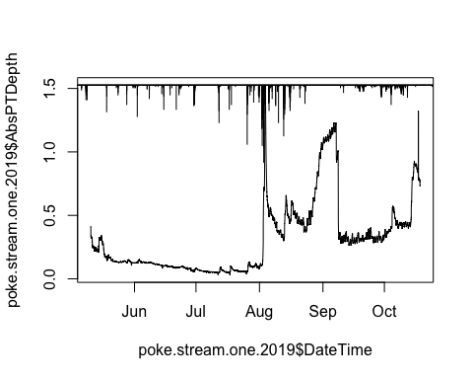 THe beginning increase appears to be real with the precip on top. I need to remove some of the "vertical bars within the data frame and check take out date. I am also going to take out the beaver dam tha is there from late august to middle of september Let the cleaning commence!

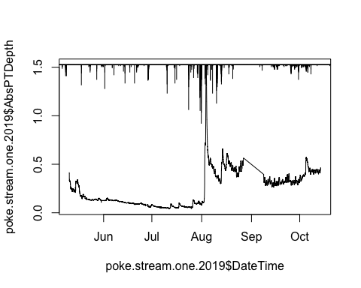 1) Removed vertical bars early on in dataset 2) Removed beaver dam related data entirely 3) removed end of season out of water points

## Raw Poker PT2

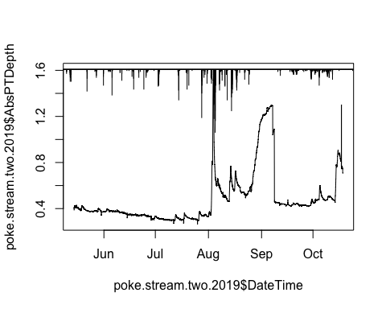 Same procedure as PT1….let the cleaning commence!

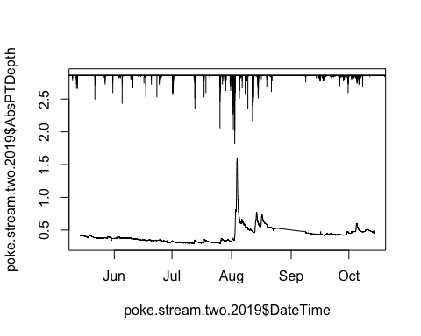 1) Removed vertical bars early on in dataset 2) Removed beaver dam related data entirely 3) removed end of season out of water points

### export PT data to csv to DoD_Discharge->PT_data->2019

### Raw Rating Curve with Poker 1 Pressure Transducer

## Joining, by = c("Site", "DateTime")

##   
## Call:  
## lm(formula = Poker1comb.2019$Q_Ls ~ Poker1comb.2019$AbsPTDepth)  
##   
## Residuals:  
## Min 1Q Median 3Q Max   
## -169.60 -59.12 -12.96 30.48 208.98   
##   
## Coefficients:  
## Estimate Std. Error t value Pr(>|t|)   
## (Intercept) 198.93 56.85 3.499 0.00809 **  
## Poker1comb.2019$AbsPTDepth 787.07 242.75 3.242 0.01184 *   
## ---  
## Signif. codes: 0 '***' 0.001 '**' 0.01 '*' 0.05 '.' 0.1 ' ' 1  
##   
## Residual standard error: 111.2 on 8 degrees of freedom  
## (13799 observations deleted due to missingness)  
## Multiple R-squared: 0.5679, Adjusted R-squared: 0.5138   
## F-statistic: 10.51 on 1 and 8 DF, p-value: 0.01184

## `geom_smooth()` using formula 'y ~ x'

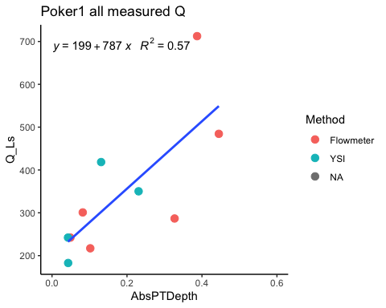 I will remove the highest flowmeter point

## Joining, by = c("Site", "DateTime")

##   
## Call:  
## lm(formula = Poker2comb.2019$Q_Ls ~ Poker2comb.2019$AbsPTDepth)  
##   
## Residuals:  
## Min 1Q Median 3Q Max   
## -98.837 -55.986 -1.269 37.849 130.892   
##   
## Coefficients:  
## Estimate Std. Error t value Pr(>|t|)   
## (Intercept) 222.06 37.73 5.886 0.000608 ***  
## Poker2comb.2019$AbsPTDepth 499.94 179.26 2.789 0.026949 *   
## ---  
## Signif. codes: 0 '***' 0.001 '**' 0.01 '*' 0.05 '.' 0.1 ' ' 1  
##   
## Residual standard error: 72.63 on 7 degrees of freedom  
## (13800 observations deleted due to missingness)  
## Multiple R-squared: 0.5263, Adjusted R-squared: 0.4587   
## F-statistic: 7.778 on 1 and 7 DF, p-value: 0.02695

## `geom_smooth()` using formula 'y ~ x'

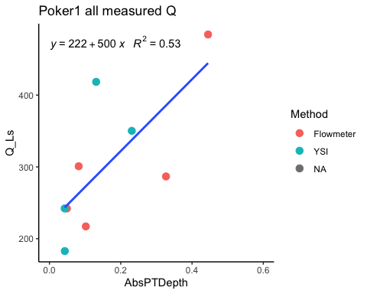 Worse R^2, Ill use the raw one

### Predicted Q POKE PT1

#### Black points are observed Q

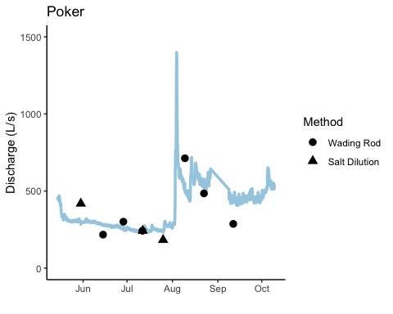

Not the worst thing I’ve seen in the world

### Raw Rating Curve with Poker 2 Pressure Transducer

## Joining, by = c("Site", "DateTime")

##   
## Call:  
## lm(formula = Poker2comb.2019$Q_Ls ~ Poker2comb.2019$AbsPTDepth)  
##   
## Residuals:  
## Min 1Q Median 3Q Max   
## -128.21 -78.42 28.37 31.08 168.99   
##   
## Coefficients:  
## Estimate Std. Error t value Pr(>|t|)   
## (Intercept) -285.8 160.2 -1.784 0.11759   
## Poker2comb.2019$AbsPTDepth 1648.8 410.9 4.012 0.00511 **  
## ---  
## Signif. codes: 0 '***' 0.001 '**' 0.01 '*' 0.05 '.' 0.1 ' ' 1  
##   
## Residual standard error: 99.57 on 7 degrees of freedom  
## (13517 observations deleted due to missingness)  
## Multiple R-squared: 0.697, Adjusted R-squared: 0.6537   
## F-statistic: 16.1 on 1 and 7 DF, p-value: 0.005109

## `geom_smooth()` using formula 'y ~ x'

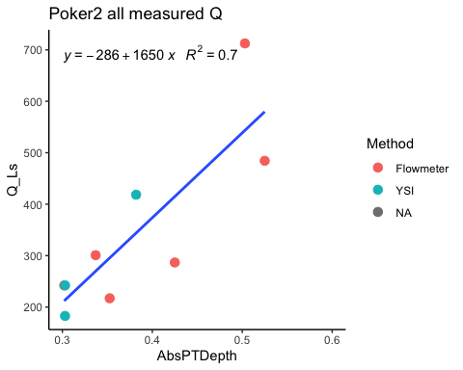 ### Predicted Q POKE PT2 #### Black points are observed Q

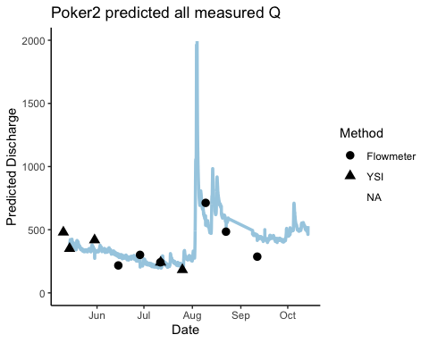

### Average POKE Q

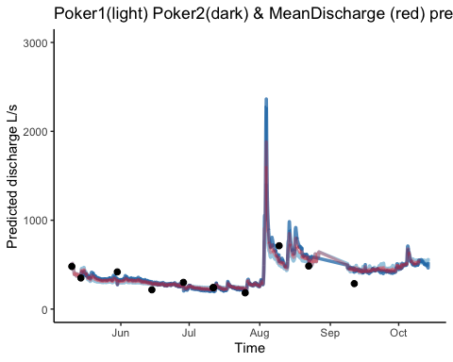

### export PT data to csv to DoD_Discharge->Predicted_Discharge->2019

## Raw Vault PT1

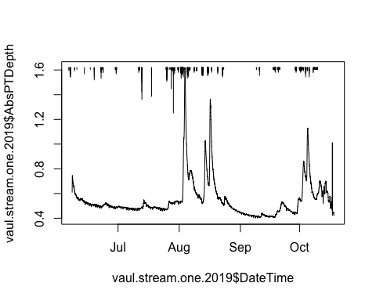 Out of water at the end of the year? Let the cleaning commence!

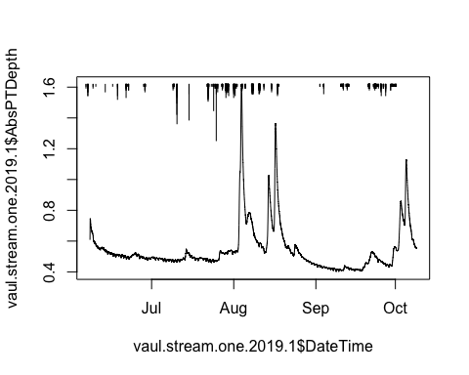 1) Removed end of record as there were erroneous points that might have been from ice on and then also out of water points

### export PT data to csv to DoD_Discharge->PT_data->2019

### Raw Rating Curve with VAUL PT1

## Joining, by = c("Site", "DateTime")

##   
## Call:  
## lm(formula = Vaultcomb.2019$Q_Ls ~ 0 + Vaultcomb.2019$AbsPTDepth)  
##   
## Residuals:  
## Min 1Q Median 3Q Max   
## -86.91 -76.88 -41.14 54.53 169.09   
##   
## Coefficients:  
## Estimate Std. Error t value Pr(>|t|)   
## Vaultcomb.2019$AbsPTDepth 200.67 58.77 3.415 0.00769 **  
## ---  
## Signif. codes: 0 '***' 0.001 '**' 0.01 '*' 0.05 '.' 0.1 ' ' 1  
##   
## Residual standard error: 94.22 on 9 degrees of freedom  
## (12731 observations deleted due to missingness)  
## Multiple R-squared: 0.5644, Adjusted R-squared: 0.516   
## F-statistic: 11.66 on 1 and 9 DF, p-value: 0.007692

## `geom_smooth()` using formula 'y ~ x'

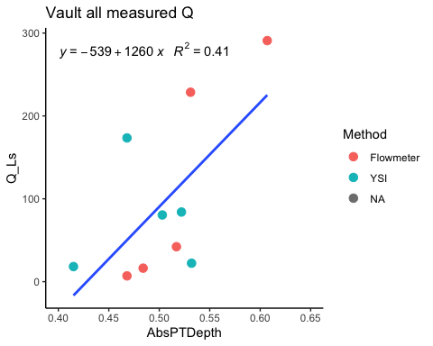 Maybe I can take the high points about the line but i am going to keep it for right now

### Predicted Q VAULPT1 #### Black points are observed Q

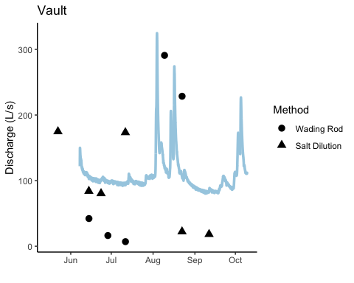 Not great…..

### export PT data to csv to DoD_Discharge->Predicted_Discharge->2019

## Raw Stuart PT1

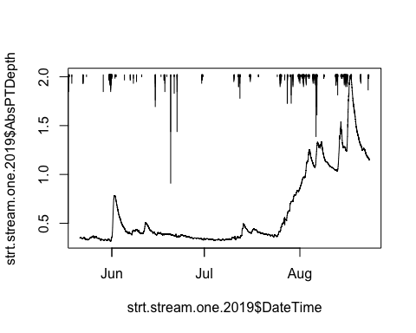 Stuart PT1 only has record until 8/23… Looks pretty clean though

## Raw Stuart PT2

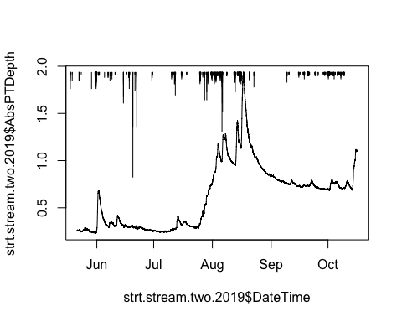 Just looks like I need to clip out the end of the season points there…Let the cleaning commence!

### STRT PT2 2.0

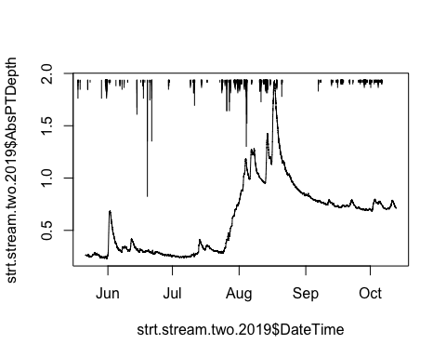 1) removed out of water points at the end of the season

### export PT data to csv to DoD_Discharge->PT_data->2019

### Raw Rating Curve with STRT PT1

## Joining, by = c("Site", "DateTime")

##   
## Call:  
## lm(formula = Stuart1comb.2019$Q_Ls ~ Stuart1comb.2019$AbsPTDepth)  
##   
## Residuals:  
## 1426 1428 2776 3447 3452 7478 8246   
## -632.66 -181.02 85.74 -141.83 810.31 -117.82 177.28   
##   
## Coefficients:  
## Estimate Std. Error t value Pr(>|t|)   
## (Intercept) -732.6 339.8 -2.156 0.083610 .   
## Stuart1comb.2019$AbsPTDepth 3823.0 446.1 8.570 0.000356 ***  
## ---  
## Signif. codes: 0 '***' 0.001 '**' 0.01 '*' 0.05 '.' 0.1 ' ' 1  
##   
## Residual standard error: 482.2 on 5 degrees of freedom  
## (9018 observations deleted due to missingness)  
## Multiple R-squared: 0.9363, Adjusted R-squared: 0.9235   
## F-statistic: 73.45 on 1 and 5 DF, p-value: 0.0003564

## `geom_smooth()` using formula 'y ~ x'

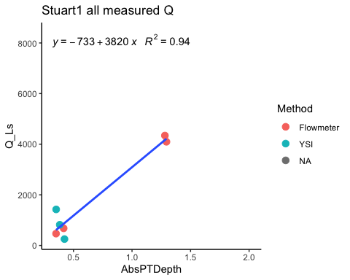 I think the first time I did this RC we ook out the two large Flowmeter calculations but then that gives us a negative relationship which makes the predicted Q really bad

### Raw Rating Curve with STRT PT2

## Joining, by = c("Site", "DateTime")

##   
## Call:  
## lm(formula = Stuart2comb.2019$Q_Ls ~ Stuart2comb.2019$AbsPTDepth)  
##   
## Residuals:  
## Min 1Q Median 3Q Max   
## -1901.7 -1326.8 -797.3 168.5 4578.9   
##   
## Coefficients:  
## Estimate Std. Error t value Pr(>|t|)   
## (Intercept) -54.74 1419.13 -0.039 0.9703   
## Stuart2comb.2019$AbsPTDepth 4905.18 1993.72 2.460 0.0434 *  
## ---  
## Signif. codes: 0 '***' 0.001 '**' 0.01 '*' 0.05 '.' 0.1 ' ' 1  
##   
## Residual standard error: 2249 on 7 degrees of freedom  
## (13854 observations deleted due to missingness)  
## Multiple R-squared: 0.4637, Adjusted R-squared: 0.3871   
## F-statistic: 6.053 on 1 and 7 DF, p-value: 0.04345

## `geom_smooth()` using formula 'y ~ x'

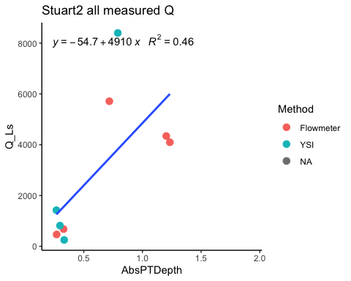 I am going to remove the high YSI pointt

### Rating Curve with STRT PT2 2.0

## Joining, by = c("Site", "DateTime")

##   
## Call:  
## lm(formula = Stuart3comb.2019$Q_Ls ~ Stuart3comb.2019$AbsPTDepth)  
##   
## Residuals:  
## Min 1Q Median 3Q Max   
## -946.69 -581.71 -458.34 -50.03 2922.95   
##   
## Coefficients:  
## Estimate Std. Error t value Pr(>|t|)   
## (Intercept) -176.8 858.4 -0.206 0.844   
## Stuart3comb.2019$AbsPTDepth 4130.2 1223.8 3.375 0.015 *  
## ---  
## Signif. codes: 0 '***' 0.001 '**' 0.01 '*' 0.05 '.' 0.1 ' ' 1  
##   
## Residual standard error: 1360 on 6 degrees of freedom  
## (13855 observations deleted due to missingness)  
## Multiple R-squared: 0.655, Adjusted R-squared: 0.5975   
## F-statistic: 11.39 on 1 and 6 DF, p-value: 0.01495

## `geom_smooth()` using formula 'y ~ x'

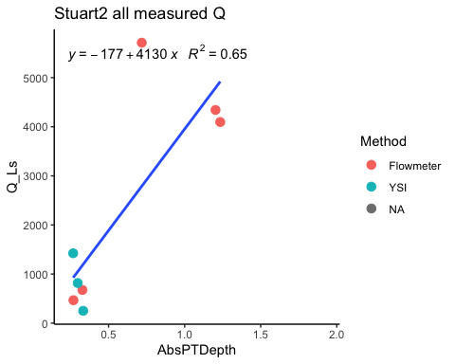 Ill remove the high flowmeter

### Rating Curve with STRT PT2 2.0

## Joining, by = c("Site", "DateTime")

##   
## Call:  
## lm(formula = Stuart4comb.2019$Q_Ls ~ Stuart4comb.2019$AbsPTDepth)  
##   
## Residuals:  
## 1426 1428 2776 3447 3452 7478 8246   
## -615.3 -171.7 85.3 -159.5 804.0 -152.3 209.5   
##   
## Coefficients:  
## Estimate Std. Error t value Pr(>|t|)   
## (Intercept) -382.6 305.0 -1.255 0.26509   
## Stuart4comb.2019$AbsPTDepth 3753.2 436.3 8.603 0.00035 ***  
## ---  
## Signif. codes: 0 '***' 0.001 '**' 0.01 '*' 0.05 '.' 0.1 ' ' 1  
##   
## Residual standard error: 480.5 on 5 degrees of freedom  
## (13856 observations deleted due to missingness)  
## Multiple R-squared: 0.9367, Adjusted R-squared: 0.9241   
## F-statistic: 74.01 on 1 and 5 DF, p-value: 0.0003501

## `geom_smooth()` using formula 'y ~ x'

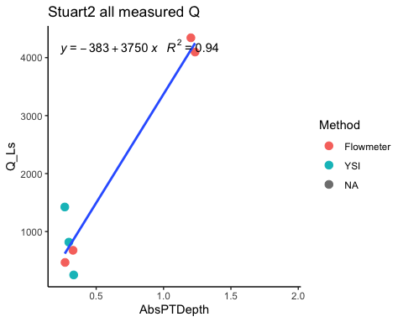 1)Removed top flowmeter and YSI point

### Predicted Q STRT PT1

#### Black points are observed Q

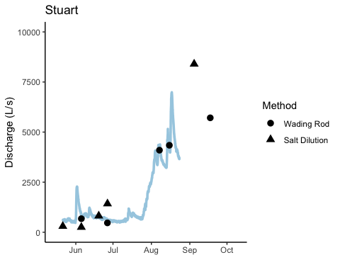

### Predicted Q STRT PT2

#### Black points are observed Q

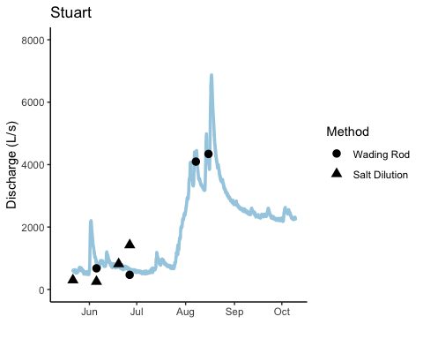

### Average STRT Q

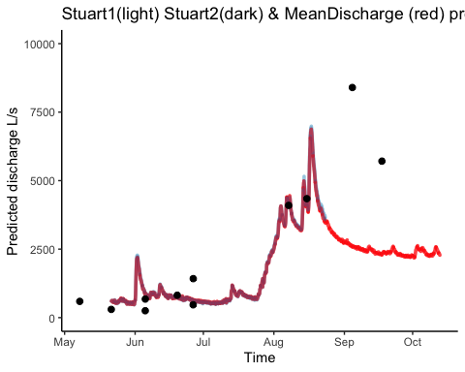

### export PT data to csv to DoD_Discharge->Predicted_Discharge->2019

### export PT data to csv to DoD_Discharge->Predicted_Discharge->2019

2020 (Moose, French, Poker, Vault, Stuart), and 2021 (Moose, French, Poker, Vault, Stuart), clean out of water points, potentially erroneous points collected, beaver dams, etc. and prepare to convert to continuous predicted discharge (Q) throuhgout the year.

2020 data is read in from DoD Project->2020 AK sensors->Discharge->Pressure Transducer->Water Level->“site”

### comparing PTs

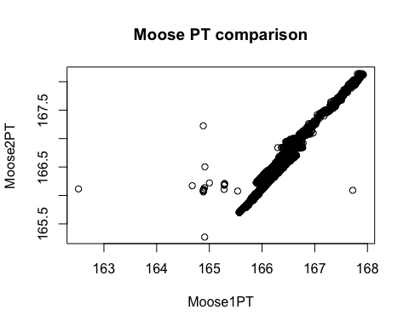 Some erroneous points but not bad. a slight shift

### comparing FRCH

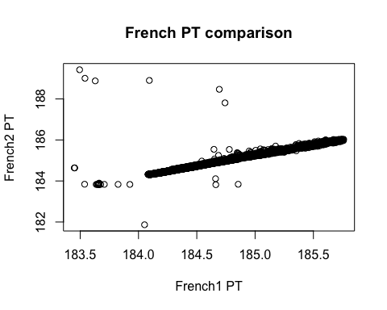 Pretty good, have to clean some of those points

### comparing FRCH

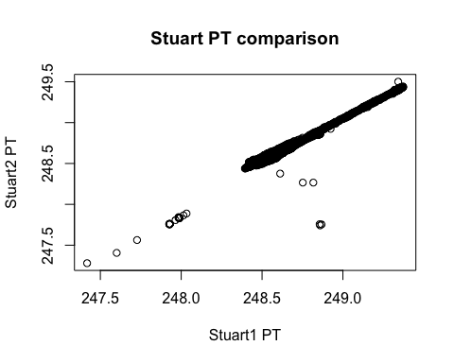

Same as French, some erroneous points that will need to be cleaned

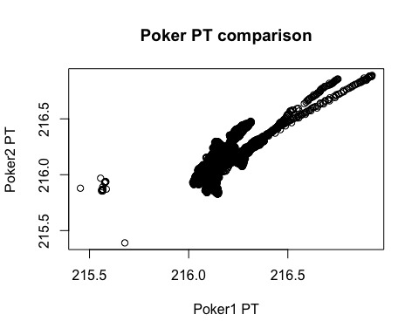 One PT is definitely more noisy

### Observed Discharge at all sites for 2020

Slugs and wading rods were used for 2020 observed Q

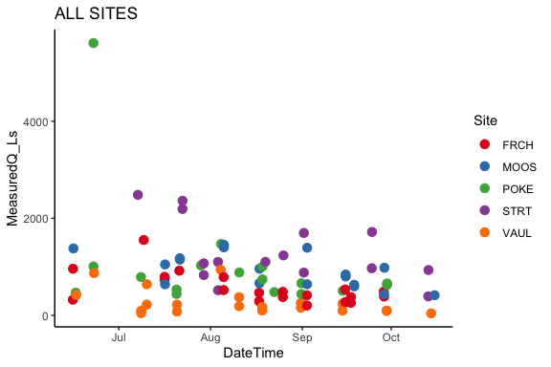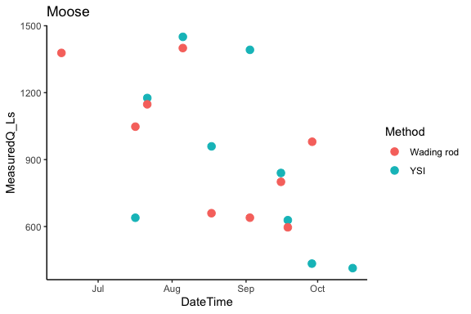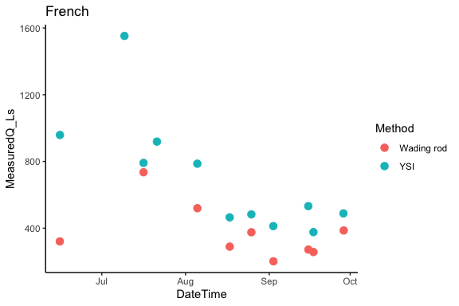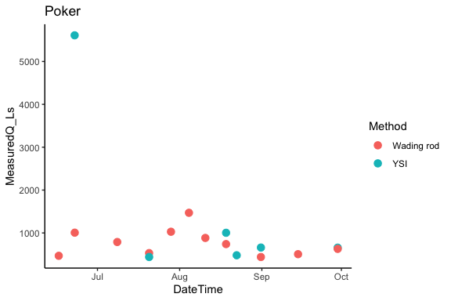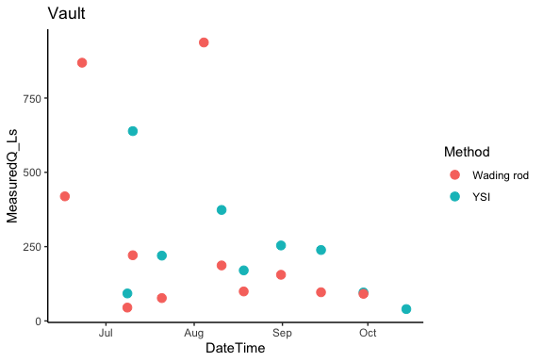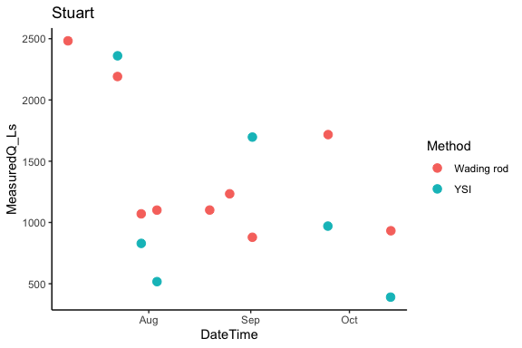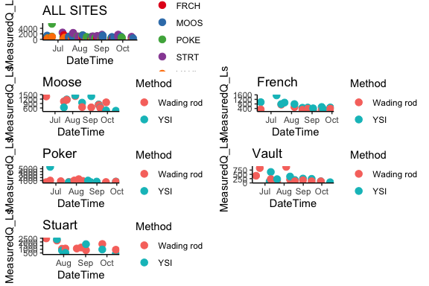

## Raw Moose PT1

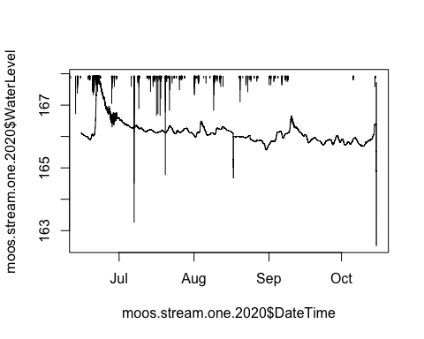 Noisy on the falling limb of first storm, potentially some out of water points in August and at the end of the season…Let the cleaning commence!

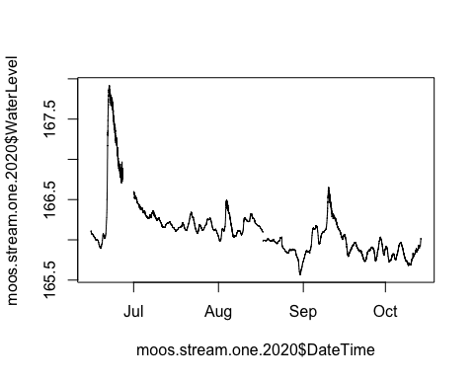

## [1] 166.093

## [1] 165.977

## [1] 0.116

## Joining, by = c("Site", "DateTimeGMT", "AbsolutePressure", "WaterLevel", "DateTime")

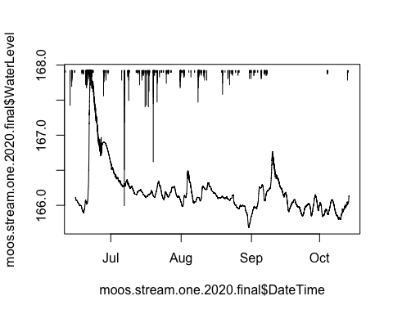 1) Clipped off data after 10/14 because thats when we took the PTs out 2) Set receding limb of first big storm in June to NA due to “noisy-ness” 3) clipped off errant points - vertical bars 4) After clipping off errant points the back half of the data after August 8/17 @ 07:00 needed to be shifted up so I took the difference of the not matched points of the data and added the difference to the data following the clip

## Raw Moose PT2

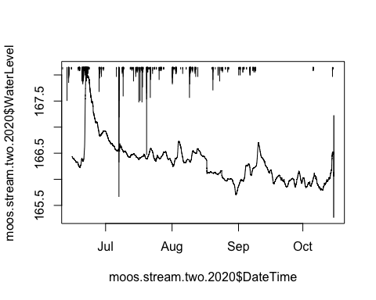 Need to adjust middle of August on and clip off out of water points associated with install or decomission

## [1] 166.361

## [1] 166.171

## [1] 0.19

## Joining, by = c("Site", "DateTimeGMT", "AbsolutePressure", "WaterLevel", "DateTime")

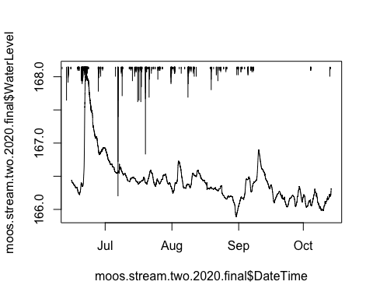 1) Clipped off data after 10/14 because thats when we took the PTs out 2) clipped off errant points (vertical bars) 3) After clipping off errant points the back half of the data after August 8/17 @ 07:00 needed to be shifted up so I took the difference of the not matched points of the data and added the difference to the data following the clip

## Export PT data to csv in DoD_Discharge->PT_data->2020

### Raw Rating Curve with MOOS PT1

## Joining, by = c("Site", "DateTime")

## `geom_smooth()` using formula 'y ~ x'

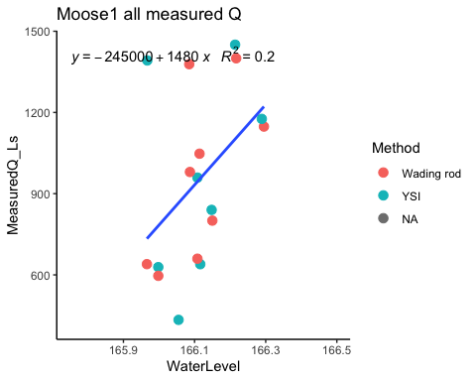 # Rating curve MOOS PT1 2.0

## Joining, by = c("Site", "DateTime")

## `geom_smooth()` using formula 'y ~ x'

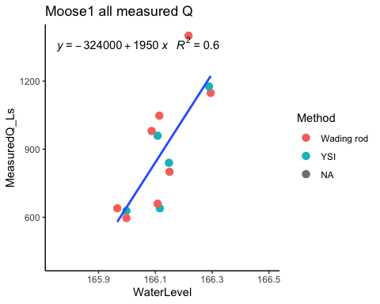 1) Removed the two highest YSI’s, lowest YSI and one of high flowmeter that wasnt a very high waterlevel

### Raw Rating Curve with MOOS PT2

## Joining, by = c("Site", "DateTime")

## `geom_smooth()` using formula 'y ~ x'

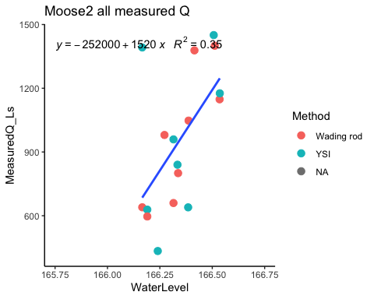

# Rating curve MOOS PT1 2.0

## Joining, by = c("Site", "DateTime")

## `geom_smooth()` using formula 'y ~ x'

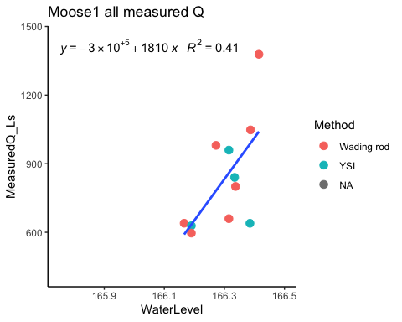 1) Removed the highest and lowest YSI # Final Q for MOOS PT1 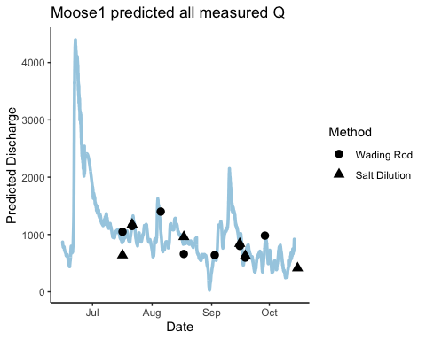 Looks pretty good

# Final Q for MOOS PT2

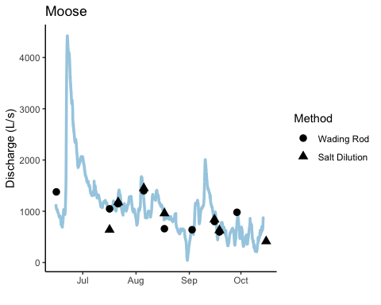 Not too shabby looking

# Average of MOOS PT1 and PT2

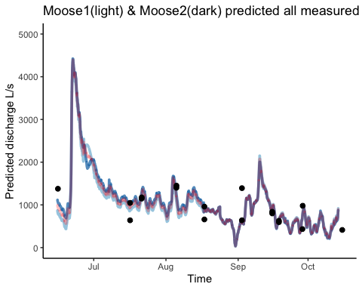 Red is the average that should be used and exported as csv.

## Export PT data to csv in DoD_Discharge->Predicted_Discharge->2020

## Raw French PT1

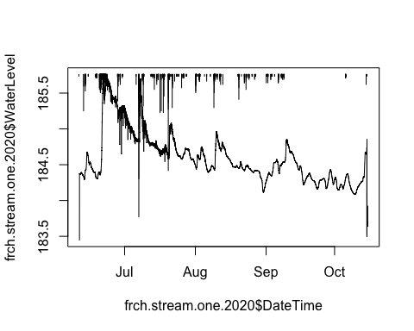 Needs cleaning for out of water points that are associated with install and decommission. Noisy on the falling limb of these storms! Let the cleaning commence!

## French PT1 2.0

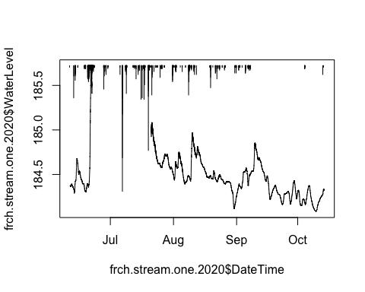 1) Removed points after October 14th (when we took out PTs) and out of water points in the beginning of the dataset 2) Removed noisy points on receding limb of big storm events in the beginning of the dataframe

## Raw French PT2

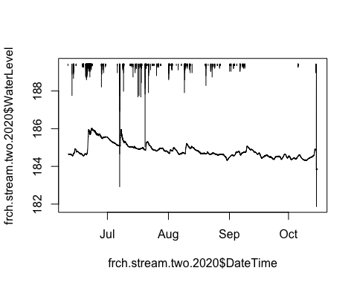 Receding limb of first initial storm is noisy on this one too

## French PT1 2.0

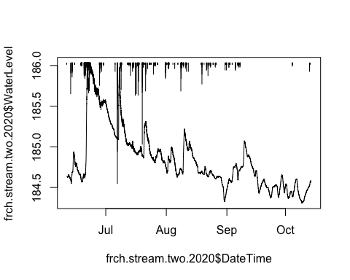 1) removed out of water points from taking out on the 14th of October

## Export PT data to csv in DoD_Discharge->PT_data->2020

# Raw Rating curve FRCH PT1

## Joining, by = c("Site", "DateTime")

## `geom_smooth()` using formula 'y ~ x'

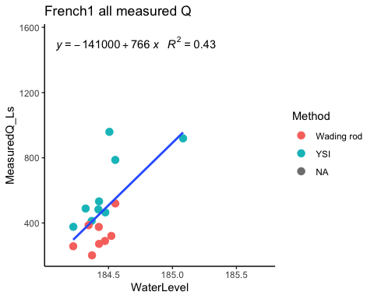

# Raw Rating curve FRCH PT1

## Joining, by = c("Site", "DateTime")

## `geom_smooth()` using formula 'y ~ x'

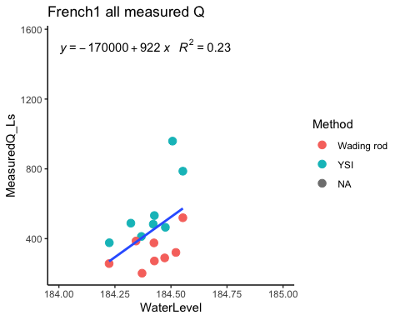 1) removed YSI with highest WL and it made R^2 worse, ill stick with the first one

# Raw Rating curve FRCH PT2

## Joining, by = c("Site", "DateTime")

## `geom_smooth()` using formula 'y ~ x'

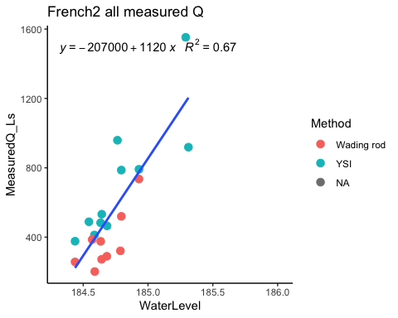 The highest YSI point could maybe go…?

# Final Q for FRCH PT1

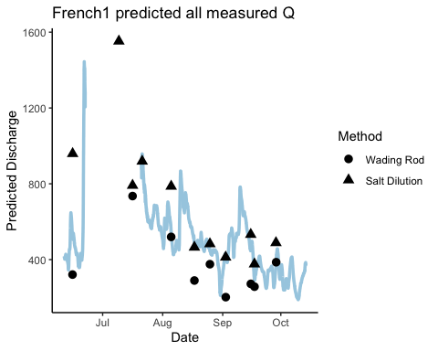

# Final Q for FRCH PT2

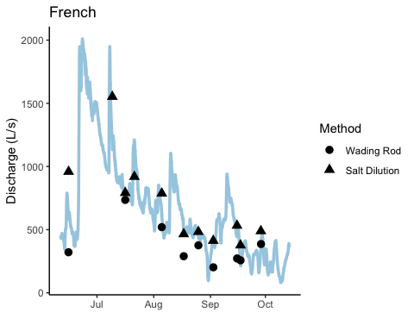 Looks pretty good

# Average Q for FRCH PT1

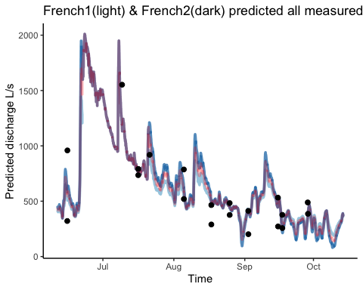 Red is the average and should be exported to a csv.

## Export PT data to csv in DoD_Discharge->Predicted_Discharge->2020

## Raw Poker PT1

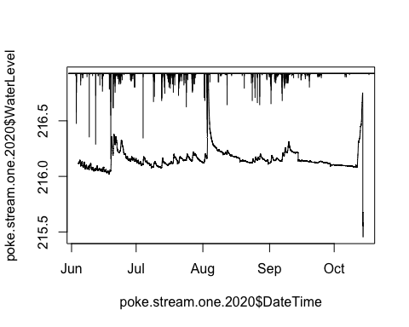 It looks like I need to remove out of water points at the end of the year and potentially shift middle of september-on up….let the cleaning commence!

## Poker PT1 2.0

## [1] 0.068

## Joining, by = c("Site", "DateTimeGMT", "AbsolutePressure", "WaterLevel", "DateTime")

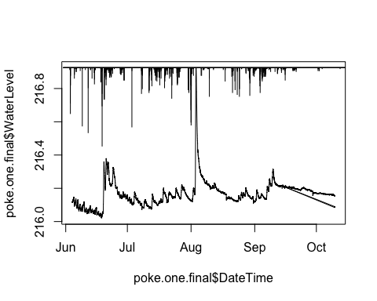 1) removed data after 10/10/20 due to decommission 2) shifted mid september-on up due to dip

## Raw Poker PT2

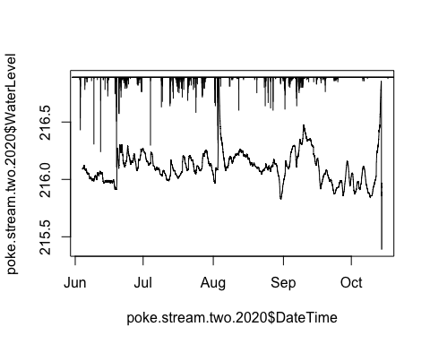 PT2 seems a lot “noisier”….this is the PT that is located on the wetttetd edge left side tucked by the meander so it is more susecptible to shaking….It also needs to be filtered out at the end of the season due to out of water points….let the cleaning commence!

## Poker PT2 2.0

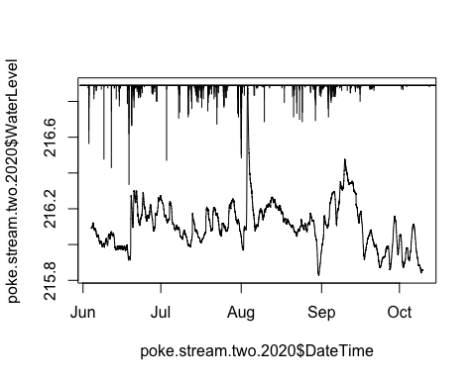

## Export PT data to csv in DoD_Discharge->PT_data->2020

# Raw Rating curve POKE PT1

## Joining, by = c("Site", "DateTime")

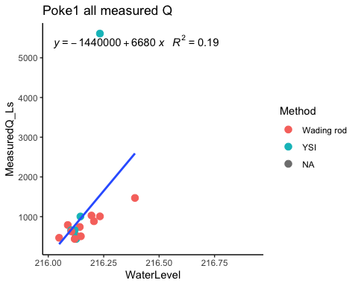 top YSI point has got to go

# Rating curve POKE PT1 2.0

## Joining, by = c("Site", "DateTime")

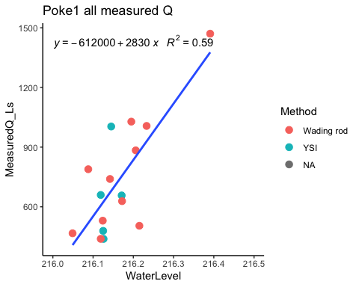 1) removed the top YSI point

# Raw Rating curve POKE PT2

## Joining, by = c("Site", "DateTime")

## `geom_smooth()` using formula 'y ~ x'

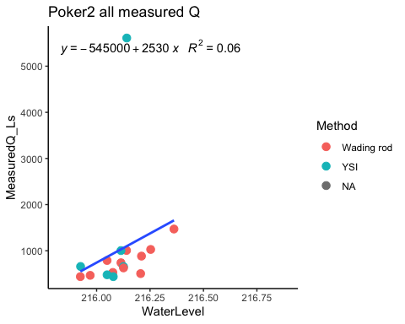 Need to remove the top YSI point

# Raw Rating curve POKE PT2

## Joining, by = c("Site", "DateTime")

## `geom_smooth()` using formula 'y ~ x'

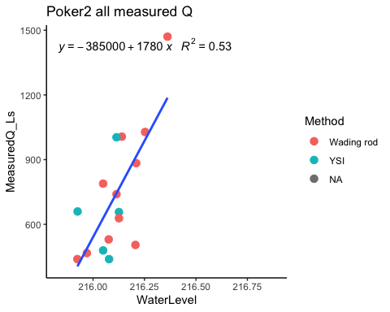 1) removed the top YSI point

# Final Q for POKE PT1

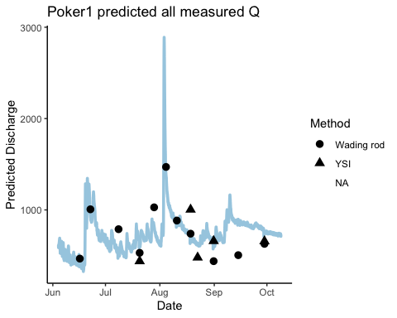 Seems like the predicted overshoots our discrete measurements

# Final Q for POKE PT2

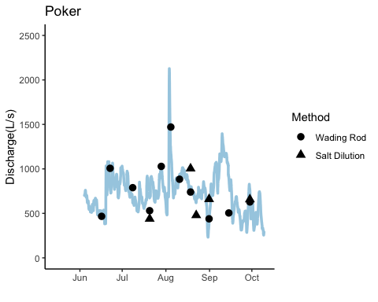 A lot noisier then PT1

# Final Q POKE average

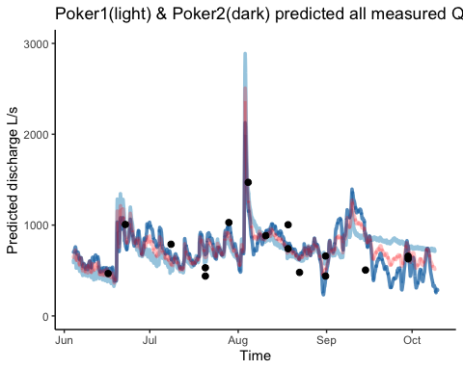 I think we should go with PT1

## Export PT data to csv in DoD_Discharge->Predicted_Discharge->2020

## Raw Vault PT1

There is only one Vault PT 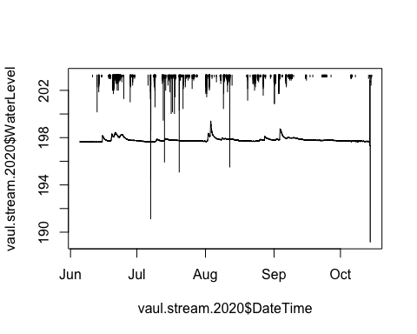 Hard to see what else we need to clean besides the end of the year out of water points….let the cleaning commence!

## Vault PT1 2.0

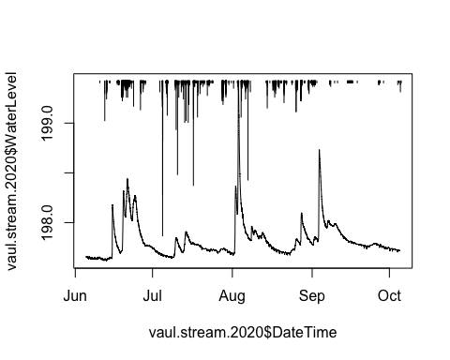 1) removed data after 10/5/20 due to out of water points

## Export PT data to csv in DoD_Discharge->PT_data->2020

## Raw rating curve for VAUL PT1

## Joining, by = c("Site", "DateTime")

## `geom_smooth()` using formula 'y ~ x'

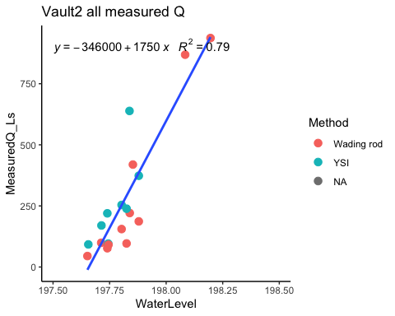 Looks pretty good…maybe that high YSI can get taken off but I would say in my experience, YSI is pretty accurate until 800 Ls so that might be good to keep

## Predicted Q for VAUL

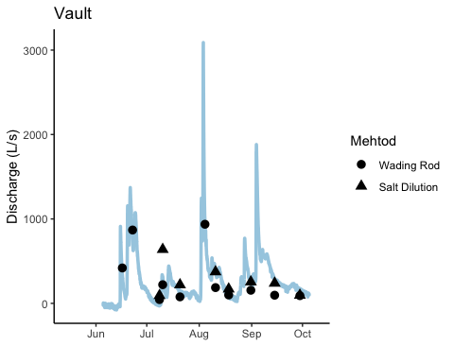 Not too shabby!

## Export PT data to csv in DoD_Discharge->Predicted_Discharge->2020

## Raw STRT PT1

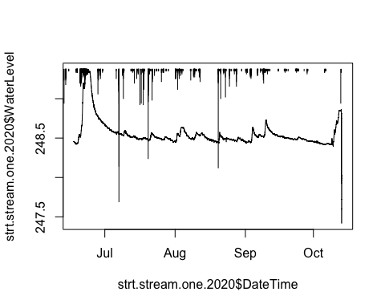 Needs end of season out of water points to be removed….let the cleaning commence!

## STRT PT1 2.0

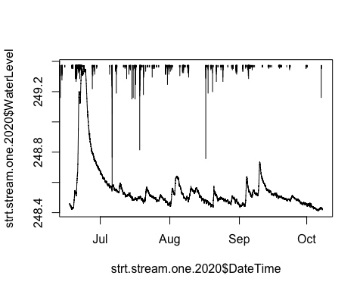 1) Removed data after 10/8/20 due to ice on the channel…PT was taken out on the 13th 2) removed vertical bar errant point in middle of August

## Raw STRT PT1

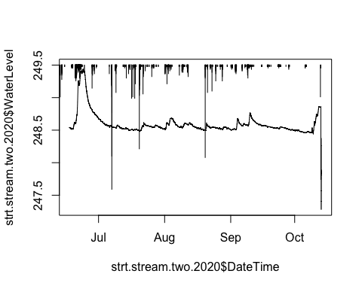 Same procedure as previous PT….let the cleaning commence!

## STRT PT1 2.0

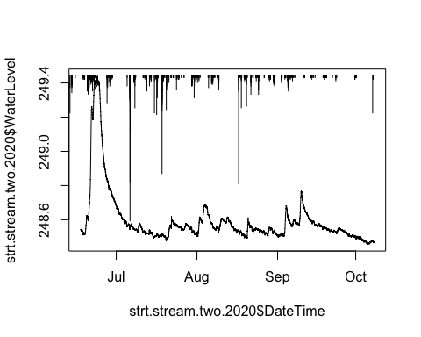 1) Removed vertical errant point at the top of first big storm 2) Removed data after 10/8 due to ice on the channel…PT was taken out on the 13th

## Export PT data to csv in DoD_Discharge->PT_data->2020

## Raw rating curve for STRT PT1

## Joining, by = c("Site", "DateTime")

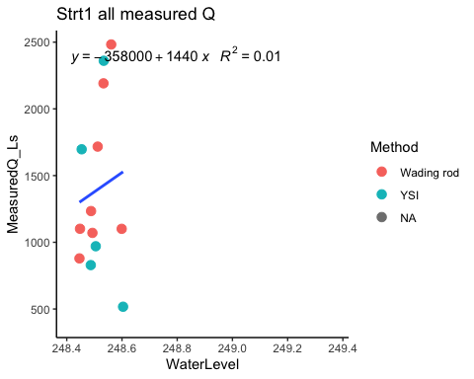 Does not look pretty

## rating curve for STRT PT1 2.0

## Joining, by = c("Site", "DateTime")

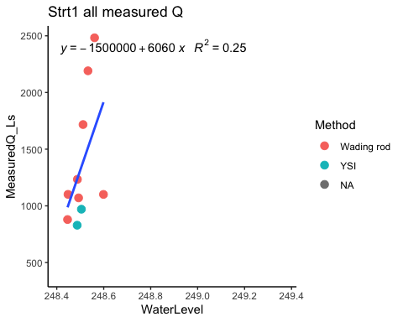 1) removed the lowest YSI and YSI’s over 1000Ls

## Raw rating curve for STRT PT2

## Joining, by = c("Site", "DateTime")

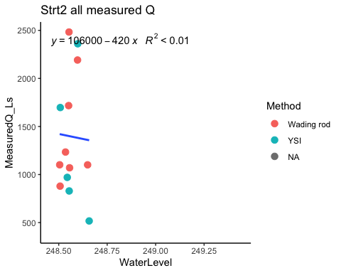 Negative slope is definitely bad

## rating curve for STRT PT2 2.0

## Joining, by = c("Site", "DateTime")

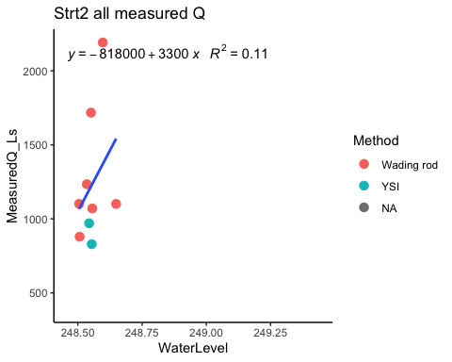 1) removed lowest YSI and YSI’s over 1000Ls 2) removed the highest Wading rod

## Predicted Q for STRT PT1

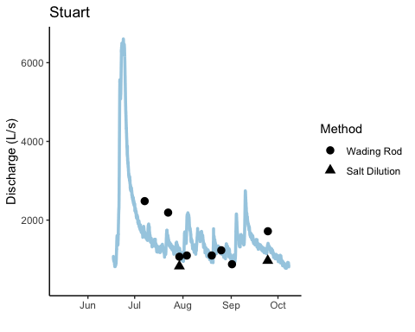 Not too shabby

## Predicted Q for STRT PT2

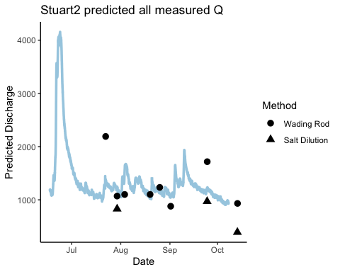 Not as good as PT1

## Average Predicted Q for STRT

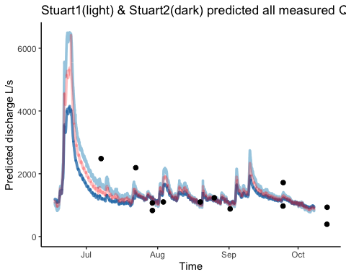

## Export PT data to csv in DoD_Discharge->Predicted_Discharge->2020

## Export PT data to csv in DoD_Discharge->Predicted_Discharge->2020

Vault, French, and Moose only have data from 6/29 on due to data not being uploaded to the drive before the computer had water damage and lost the data….reminder to ALWAYS BACK UP DATA. We can try and run a model to apply data from Poker to extrapolate missing water level points at other sites.

2021 data comes from DoD Project-> 2021 AK sensors -> Discharge->PT->‘site’

2021 data was taken using a Wading rod and salt slug dilution and an ADCP at Stuart and Moose one time during the season.

### comparing PTs

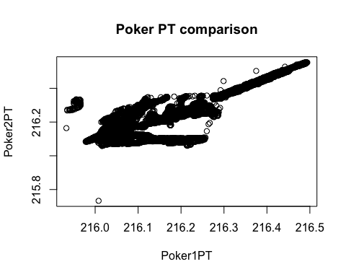 ### STRT Comp 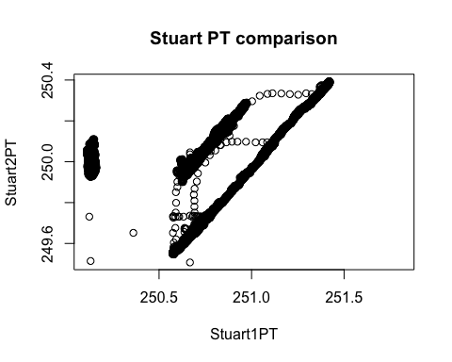 ### FRCH COMP 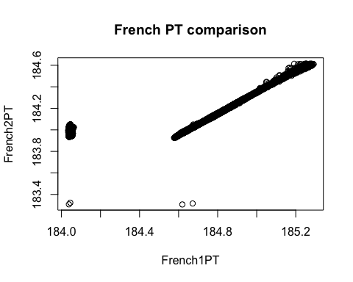 ### MOOS comp 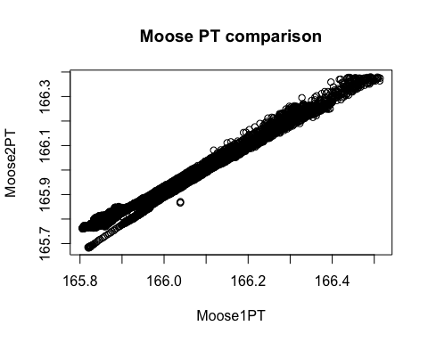

### Raw Moose PT1

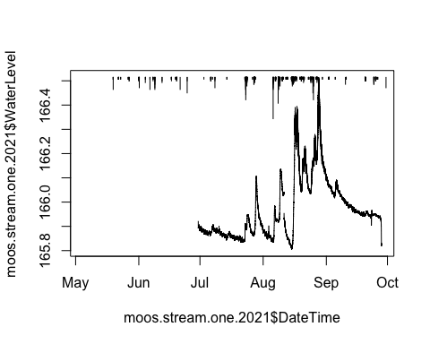 Need to clean out of water points at the end of the dataframe…let the cleaning commence!

### Moose PT1 2.0

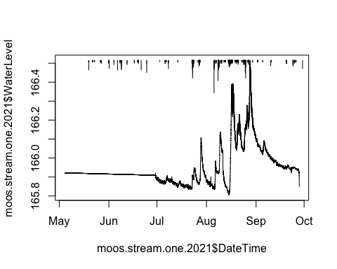 1) removed out of water points during decommission on 9/28/21 2) removed vertical errant points in middle of September

### Raw Moose PT2

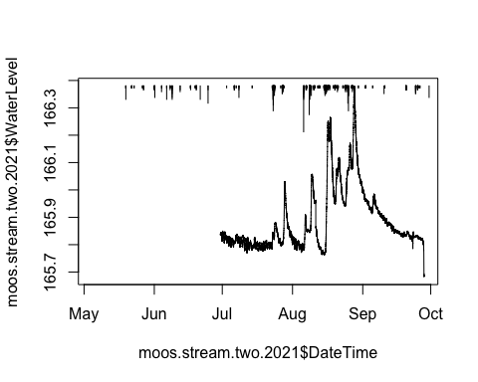 Need to remove out of water points associated with decommission…let the cleaning commence!

### Moose PT2 2.0

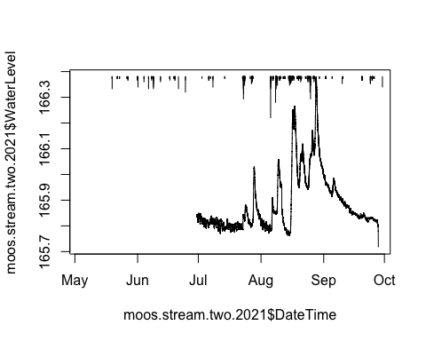

## Export PT data to csv in DoD_Discharge->PT_data->2021

## Raw rating curve for MOOS PT1

## Joining, by = c("Site", "DateTime")

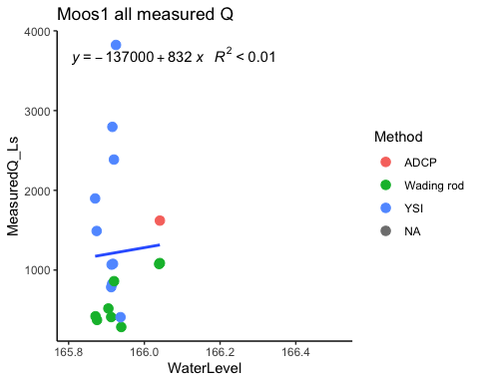 High YSI pints will have to be removed

### MOOS PT1 2.0

## Joining, by = c("Site", "DateTime")

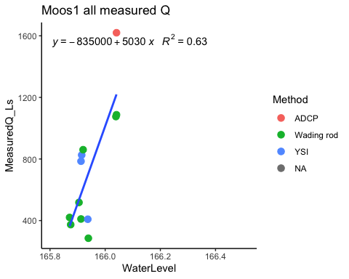 1) removed YSI points above 1000 Ls

## Raw rating curve for MOOS PT2

## Joining, by = c("Site", "DateTime")

## `geom_smooth()` using formula 'y ~ x'

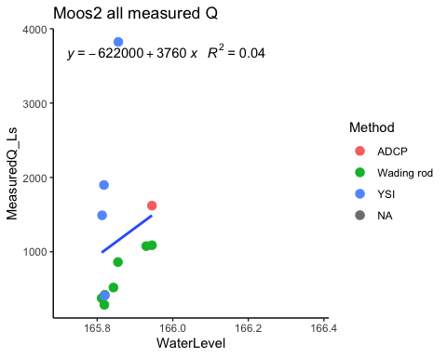 Need to remove YSI’s

### MOOS PT2

## Joining, by = c("Site", "DateTime")

## `geom_smooth()` using formula 'y ~ x'

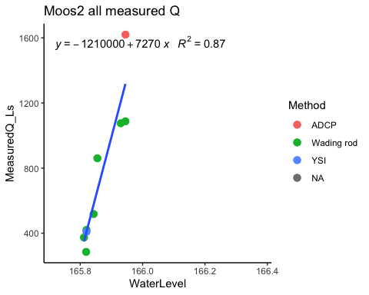 1) removed YSI points above 1000 Ls

### Predicted Q MOOS PT1

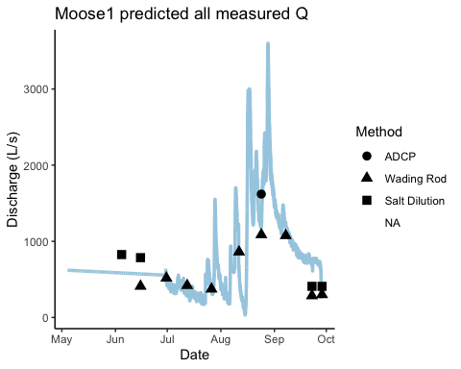 Not too shabby

### Predicted Q MOOS PT2

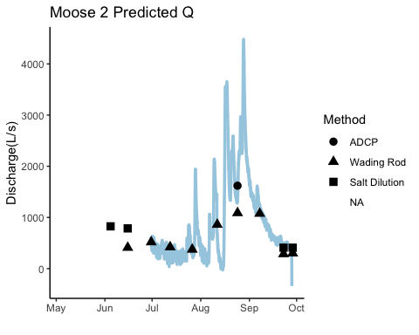 Nott too shabby

### Average predicted Q MOOS

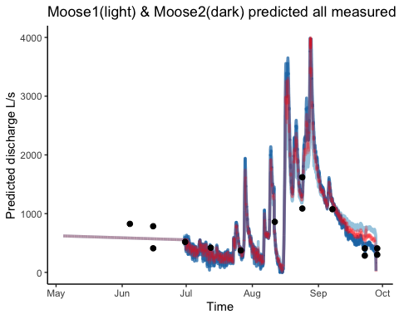 Looks good and red should be exported as a csv

## Export PT data to csv in DoD_Discharge->Predicted_discharge->2021

### Raw French PT1

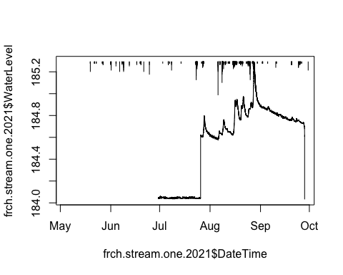

It appears that I need to shift the July data up to what it looks like to the end of July and take the out of water points associated with decommission out of data frame

### French PT1 2.0

## [1] 0.568

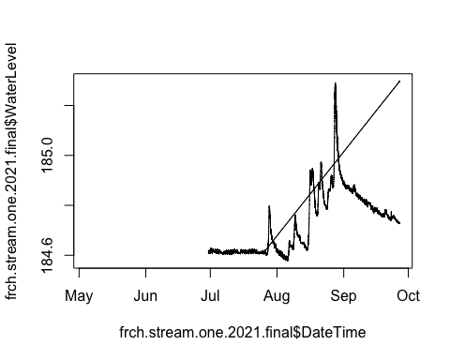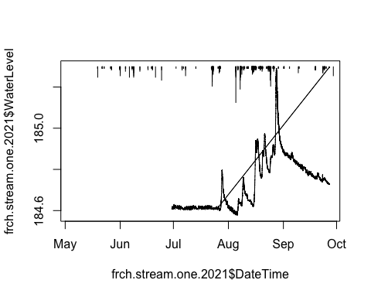 1) removed out of water points associated with decommission 2) shifted July data up to the rest of the data set due with cleaning

### Raw French PT2

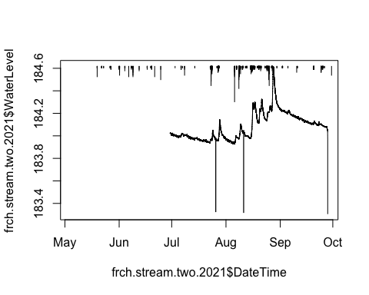

### French PT2 2.0

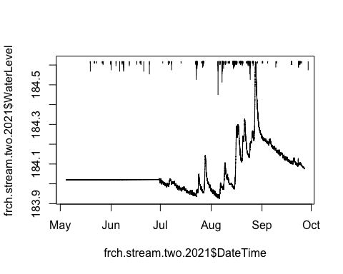 Not too shabby

## Export PT data to csv in DoD_Discharge->PT_data->2021

### Raw Rating curveFrench PT1

## Joining, by = c("Site", "DateTime")

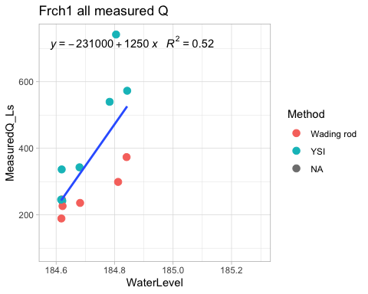 Maybe take out the top YSI point

### Rating curve French PT1 2.0

## Joining, by = c("Site", "DateTime")

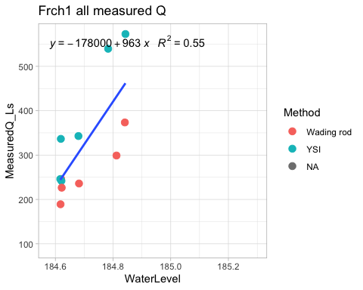 1) removed the top YSI points

### Raw Rating curve French PT2

## Joining, by = c("Site", "DateTime")

## `geom_smooth()` using formula 'y ~ x'

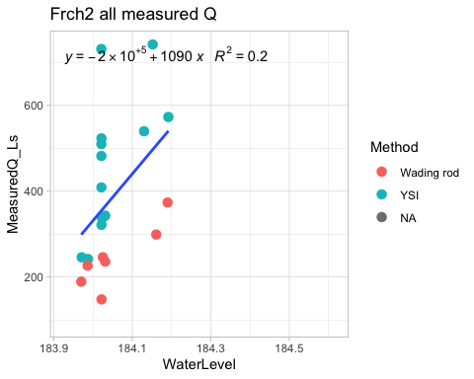

### Rating curve French PT2 2.0

## Joining, by = c("Site", "DateTime")

## `geom_smooth()` using formula 'y ~ x'

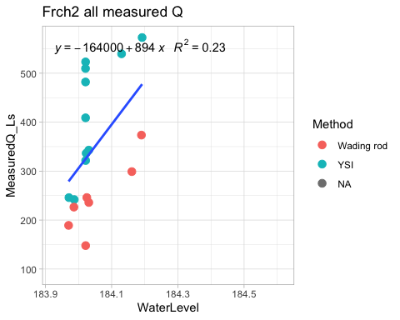 1) removed the top YSI points

### Predicted Q FRCH PT1

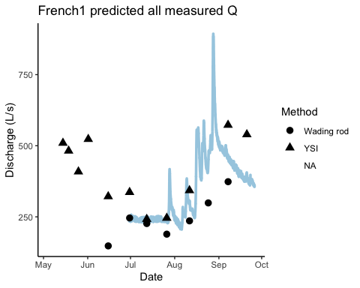

### Predicted Q FRCH PT2

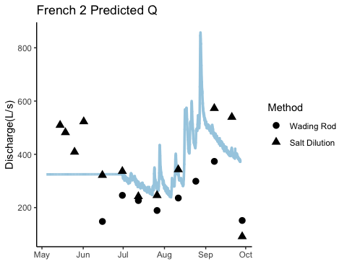 Not too shabby

### Predicted Q FRCH PT2

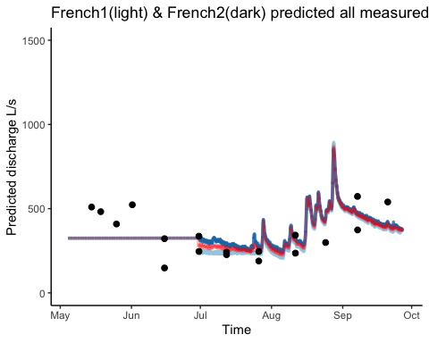 Red should be exported as a csv

## Export PT data to csv in DoD_Discharge->Predicted_discharge->2021

### Raw Poker PT1

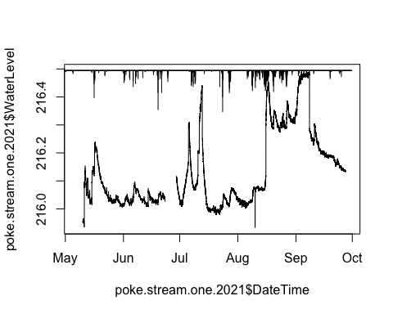 2 beaver dams in July and one in the beginning of september….let the cleaning commence!

### Poker PT2 2.0

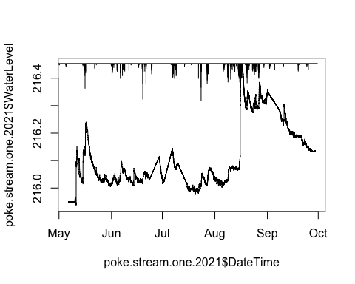 1) Removed beaver dam raise in water level in the beginning, middle of July and beginning of September 2) check the middle of August

### Raw Poker PT2

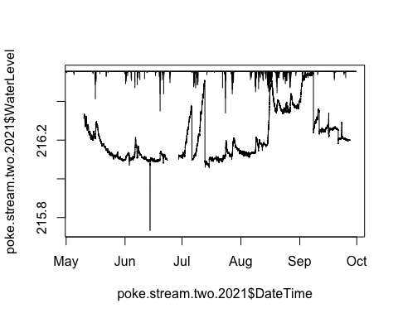 Out of water point in June, beaver dams….let the cleaning commence!

### Poker PT2 2.0

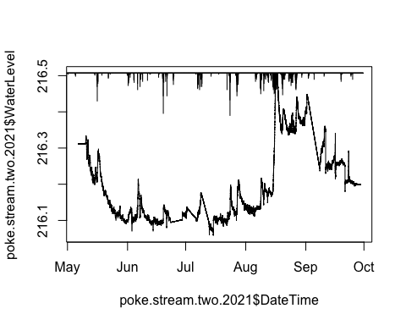 1) Removed beaver dam raise in water level in the beginning, middle of July and beginning of September 2) check the middle of August

## Export PT data to csv in DoD_Discharge->PT_data->2021

### Raw Rating curve Poker PT1

## Joining, by = c("Site", "DateTime")

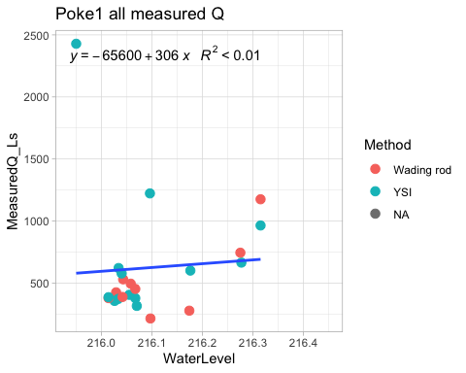 Will remove high YSI

### Rating curve Poker PT1 2.0

## Joining, by = c("Site", "DateTime")

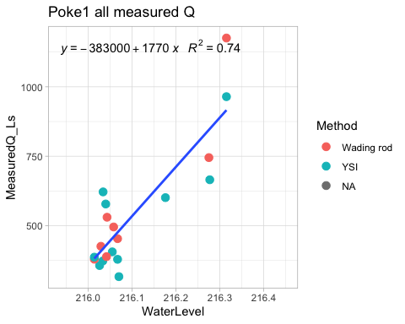 1) Removed highest YSI and 2) Removed lowest Wading rods

### Raw Rating curve Poker PT2

## Joining, by = c("Site", "DateTime")

## `geom_smooth()` using formula 'y ~ x'

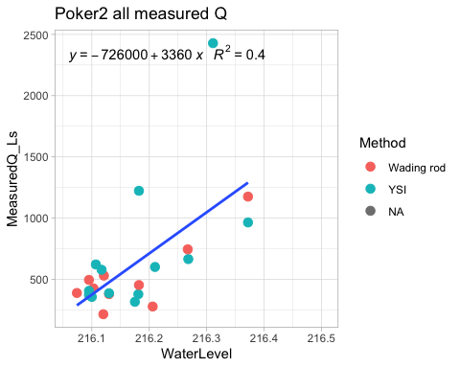 will remove highest YSI and lowest wading rods

### Rating curve Poker PT1 2.0

## Joining, by = c("Site", "DateTime")

## `geom_smooth()` using formula 'y ~ x'

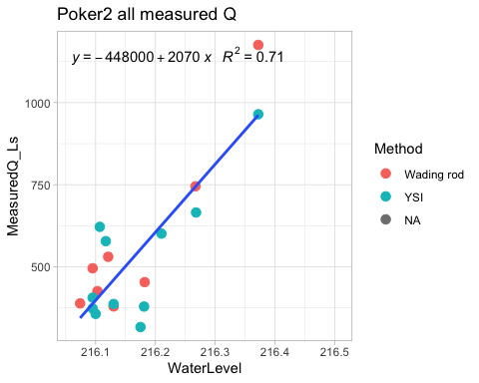 1) Removed highest YSI and 2) Removed lowest Wading rods

### Predicted Q for POKE PT1

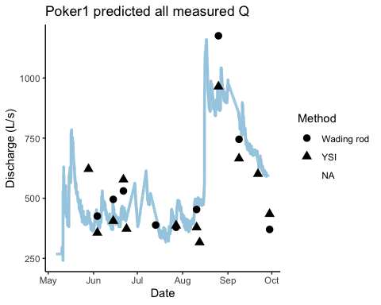 Not the prettiest thing I have ever seen

### Predicted Q for POKE PT2

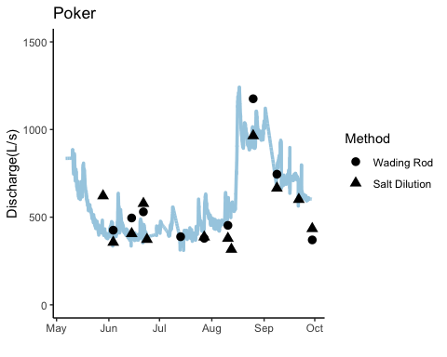 Looks better then PT1…snowmelt signature looks good

### Average Q for POKE

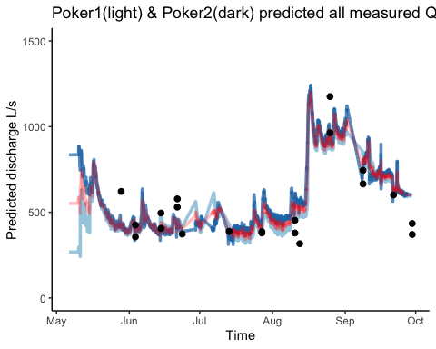 I think I should clip off the beginning of PT1 as the snowmelt signature makes more sense in PT2…what do you think?

## Export PT data to csv in DoD_Discharge->Predicted_discharge->2021

### Raw Vault PT1

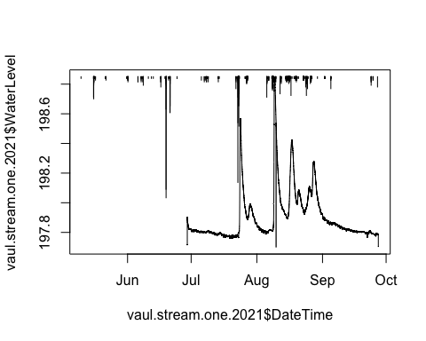

Need to remove vertical bars associated with out of water points such as the beginning and the end of the dataframe

### Vault PT1 2.0

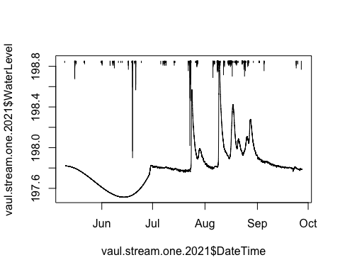 1) Removed vertical bars errant points in the beginning of the dataframe as well the middle of the first big storm and the end of the dataframe

## Export PT data to csv in DoD_Discharge->PT_data->2021

### Raw VAUL rating curve

## Joining, by = c("Site", "DateTime")

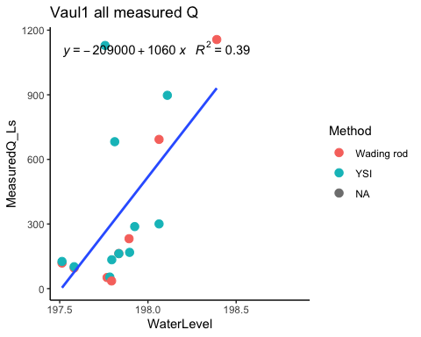 Best raw one yet!

### Predicted Q for VAUL

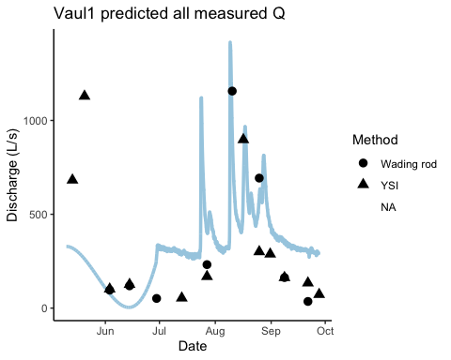 Not too shabby

## Export PT data to csv in DoD_Discharge->Predicted_discharge->2021

### Raw STRT PT1

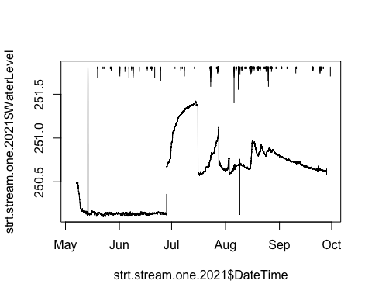 Need to shift beginning of dataframe up and remove beaverr dam in July…remove errant vertical bars

### STRT PT1 2.0

## [1] 0.543

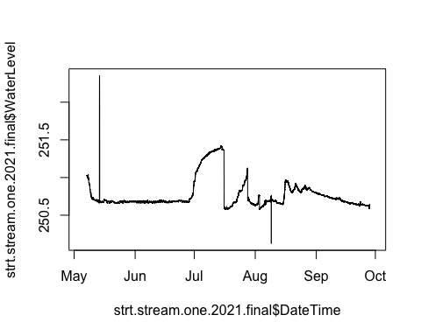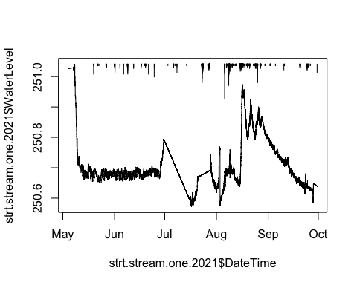 1) Removed errant vertical bar points 2)Removed beaver dam raises in Water level Quick snowmelt period and then not a lot of waterlevel change in June.

### Raw STRT PT2

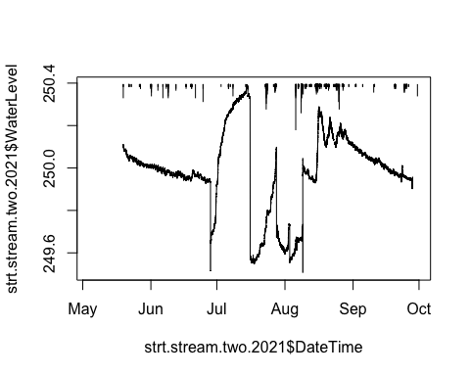

### STRT PT2 2.0

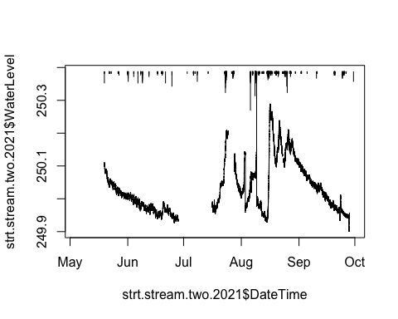 1) removed beaver dams 2) removed errant vertical bars 3) shifted middle of july to middle of August

## Export PT data to csv in DoD_Discharge->PT_data->2021

### Raw STRT rating curve

## Joining, by = c("Site", "DateTime")

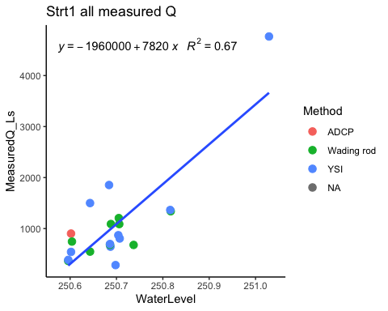

### STRT rating curve 2.0

## Joining, by = c("Site", "DateTime")

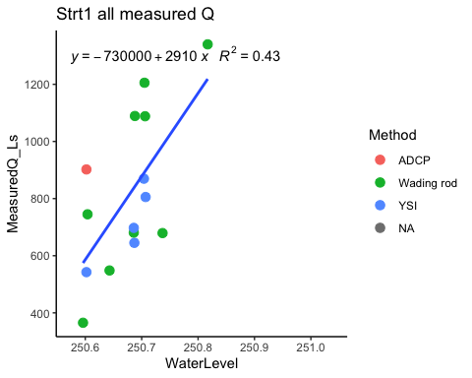 1) Removed highest and lowest YSIs

### Raw STRT rating curve PT2

## Joining, by = c("Site", "DateTime")

## `geom_smooth()` using formula 'y ~ x'

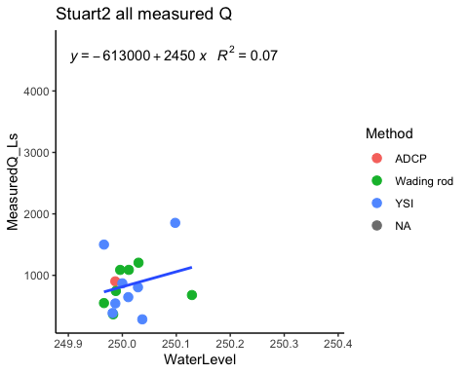

### STRT rating curve PT2 2.0

## Joining, by = c("Site", "DateTime")

## `geom_smooth()` using formula 'y ~ x'

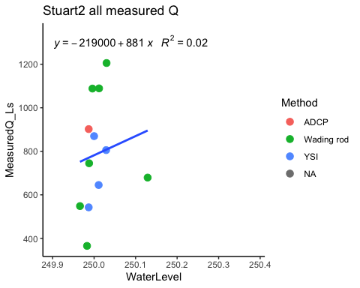 1)Removed lowest and highest YSIs Not as good as PT1

### Predicted Q STRT PT1

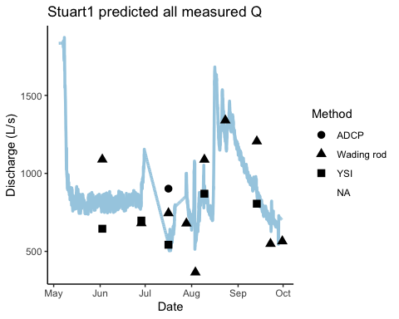 Icky

### Predicted Q STRT PT2

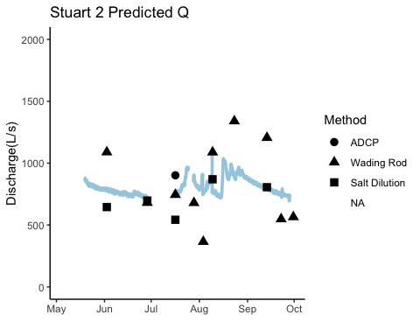 Icky

### Average Q for STRT

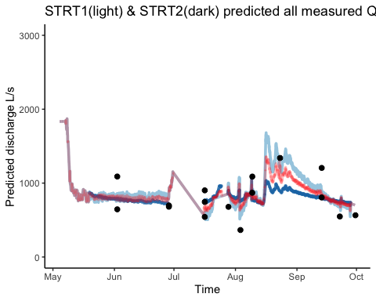 ICKY

## Export PT data to csv in DoD_Discharge->Predicted_discharge->2021

## Export PT data to csv in DoD_Discharge->Predicted_discharge->2021

### Average Q for STRT

